

|  |  |  |
| --- | --- | --- |
| DevOps | | |
| Lab Manual | | |
| **Department of Computer Science and Engineering**  **The NorthCap University, Gurugram** | | |
|  | |
|  | |
|  | |
|  | |
|  |

**DevOps Lab Manual**

**CSL373**

Anand Sehgal



Department of Computer Science and Engineering

The NorthCap University, Gurugram- 122001, India

Session 2021-22

*Published by:*

**School of Engineering and Technology**

**Department of Computer Science & Engineering**

**The NorthCap University Gurugram**

**• Laboratory Manual is for Internal Circulation only**

**© Copyright Reserved**

*No part of this Practical Record Book may be*

*reproduced, used, stored without prior permission of The NorthCap University*



Copying or facilitating copying of lab work comes under cheating and is considered as use of unfair means. Students indulging in copying or facilitating copying shall be awarded zero marks for that particular experiment. Frequent cases of copying may lead to disciplinary action. Attendance in lab classes is mandatory.

Labs are open up to 7 PM upon request. Students are encouraged to make full use of labs beyond normal lab hours.

**PREFACE**

NoSQL DatabasesLab Manual is designed to meet the course and program requirements of NCU curriculum for B.TechV year students of CSE branch. The concept of the lab work is to give brief practical experience for basic lab skills to students. It provides the space and scope for self-study so that students can come up with new and creative ideas.

The Lab manual is written on the basis of “teach yourself pattern” and expected that students who come with proper preparation should be able to perform the experiments without any difficulty. Brief introduction to each experiment with information about self-study material is provided.Students are expected to come thoroughly prepared for the lab.General disciplines, safety guidelines and report writing are also discussed.

The lab manual is a part of curriculum for TheNorthCap University, Gurugram. Teacher’s copy of the experimental results and answer for the questions are available as sample guidelines.

We hope that lab manual would be useful to students of CSE, IT, ECE and BSc branches and author requests the readers to kindly forward their suggestions / constructive criticism for further improvement of the work book.

Author expresses deep gratitude to Members, Governing Body-NCU for encouragement and motivation.

**Authors**

**The NorthCap University**

**Gurugram, India**

|  |  |  |  |
| --- | --- | --- | --- |
| **CONTENTS** | | | |
| S.N. | **Details** | Page No. | |
|  | **Syllabus** |  | |
| 1 | **Introduction** |  | |
| 2 | **Lab Requirement** |  |
| 3 | **General Instructions** |  |
| 4 | **List of Experiments** |  |
| 5 | **List of Flip Assignment** |  |
| 6 | **List of Projects** |  |
| 7 | **Rubrics** |  |
| 8 | **Annexure 1 (Format of Lab Report)** |  |
| 9 | **Annexure 2 (Format of Lab Certificate)** |  |

**SYLLABUS**

|  |  |  |  |  |  |  |  |  |
| --- | --- | --- | --- | --- | --- | --- | --- | --- |
| 1. **Department:** | | | **Department of Computer Science and Engineering** | | | | | |
| 1. **Course Name:** DevOps | | | | | 1. **Course Code** | | 1. **L-T-P** | 1. **Credits** |
| CSL373 | | 2-0-4 | 4 |
| 1. **Type of Course (Check one):** | | | **✓**  Programme Core Programme Elective Open Elective | | | | | |
| 1. **Pre-requisite(s), if any:** FOCP II | | | | | | | | |
| 1. **Frequency of offering (check one):** Odd Even **✓**Either semester Every semester | | | | | | | | |
| 1. **Brief Syllabus:**   DevOps is a fast-growing field that bridges the gap between software developers and operations. This course is the first course of a two-course module and covers the foundational principles of DevOps involving continuous development and deployment, automation of configuration management, inter-team collaboration and IT service agility, using modern DevOps tools such as Git, Docker and Jenkins. The course will help become a DevOps practitioner who can apply the latest principles in DevOps methodology to automate software development lifecycle. | | | | | | | | |
| **Total lecture, Tutorial and Practical Hours for this course (Take 15 teaching weeks per semester):** 90 | | | | | | | | |
| **Lectures:** 30 hours | | | | **Practice** | | | | |
| **Tutorials:** 0 hours | | **Lab Work:** 60 hours | | |
| 1. **Course Outcomes (COs)**   Possible usefulness of this course after its completion i.e. how this course will be practically useful to him once it is completed. | | | | | | | | |
| **CO 1** | Understanding the objectives of DevOps and the associated vocabulary to create real time projects and manage them. | | | | | | | |
| **CO 2** | Analyze DevOps relationship with Agile, Lean and ITSM to select correct CI/CD pipeline. | | | | | | | |
| **CO 3** | Building CI / CD pipeline to support developer and operations team to work together. | | | | | | | |
| **CO 4** | Applying automation practices including deployment pipelines and DevOps toolchains to develop projects using Maven and Docker. | | | | | | | |
| **CO 5** | Create DevOps scaling for enterprise to explain how development and operations works in real time project where students learn to apply coding, testing and deployment of the project. | | | | | | | |
| 1. **UNIT WISE DETAILS No. of Units: 5** | | | | | | | | |
| **Unit Number: 1** | | **Title: Introduction to Devops** | | | | | **No. of hours: 5** | |
| **Content Summary:**  Introduction to DevOps, Agile, Continuous Integration, Continuous Delivery and the Three Ways; Principles of Flow, Principles of Feedback and The Principles of Continual Learning and Experimentation, Continuous Deployment, DevOps Practices, Relationship between Agile and DevOps, Differences between DevOps and Traditional approach, Overview of DevOps tools, Categories of DevOps tools, CI/CD Pipeline, Operational Methodologies: ITIL, COBIT, System Methodologies: LEAN. | | | | | | | | |
| **Unit Number: 2** | | **Title: DevOps tools – Maven** | | | | | **No. of hours: 5** | |
| **Content Summary:**  Maven Introduction, Features of Maven in DevOps, Installation and working of Maven, Core concepts of Maven, Maven Repositories, Maven Architecture, Pros and Cons of Maven, Project Object Model, Build Life-Cycle, Build Profiles, Creating Project using Maven, Build and Test Project, Repositories and Plug-ins. | | | | | | | | |
| **Unit Number: 3** | | **Title: DevOps Tools: Docker** | | | | | **No. of hours: 8** | |
| **Content Summary:**  Docker Overview, Benefits and Use of Docker, Installation and Configuration, Running the first container, Working with Containers, Docker Hub, Images: Docker Image Basics, Building our own image, Pushing images to Docker Hub, Docker Architecture, Docker Engine, Docker Networking Basics, Testing with Docker: Using Docker to test a Static Website | | | | | | | | |
| **Unit Number: 4** | | **Title: DevOps Tools: Kubernetes** | | | | | **No. of hours: 8** | |
| **Content Summary:**  Kubernetes Basics, why use Kubernetes, Features and Architecture, Installation and Setup, Images, Jobs, Labels and Selectors, Namespace, Node, Service, Pod, creating a Kubernetes Cluster, Deploy an app. | | | | | | | | |
| **Unit Number: 5** | | **Title: DevOps Tools: Jenkins** | | | | | **No. of hours: 4** | |
| **Content Summary:**  Overview and Installation of Jenkins, Preparing Environment and Setting up Jenkins, creating a new job with Jenkins, Running Jenkins job, Configuring Tools and Jenkins Server, Configuration of build tools with Jenkins, Build Job, Testing. | | | | | | | | |
| 1. **Brief Description of Self-learning components by students (through books/resource material etc.):**  * Dockers command help can be found on: docs.docker.com * Containers command practice can be found on Kubernetes documentation: kubernetes.io/docs/home/   Some on-line MOOC courses can be found on e-learning platforms:   * https://www.edx.org/learn/devops * https://www.coursera.org/learn/ibm-containers-docker-kubernetes-openshift * https://alison.com/course/diploma-in-devops-engineering-kubernetes-docker-and-google-cloud | | | | | | | | |
| 1. **Advance Learning Components**  * Learn Docker and Containers using Interactive Browser Based Labs:   + https://www.katacoda.com/courses/docker * Visual web terminal – A Turbocharged command Line command line for Kubernetes and OpenShift   + https://www.openshift.com/blog/visual-web-terminal-a-turbocharged-command-line-for-kubernetes-and-openshift * KubeBox – Terminal and web console for Kubernetes   + https://github.com/astefanutti/kubebox * Certification programs   + https://devopsinstitute.com/certifications/   + https://www.udacity.com/course/cloud-dev-ops-nanodegree--nd9991   + https://www.cognixia.com/course/advanced-devops-training-certification-course | | | | | | | | |
| 1. **Books Recommended:**   **Textbooks:**   1. Gene Kim, Patrick Debois, John Willis, Jez Humble, “The Devops Handbook: How to Create World-Class Agility, Reliability, and Security in Technology Organizations”, IT Revolution Press,1st edition, 2016 2. Jennifer Davis, Ryn Daniels, “Effective DevOps: Building a culture of Collaboration, Affinity and Tooling at Scale” O'Reilly Media, 1st Edition, 2016   **Reference Books:**   1. James Turnbull, ‘The Docker Book: Containerization is the new virtualization’, Amazon Asia-Pacific Holdings Private Limited, 1st edition   **Reference Websites: (nptel, swayam, coursera, edx, udemy, lms, official documentation weblink)**   * https://www.docker.com/ * https://maven.apache.org/ * https://kubernetes.io/docs/tutorials/ * <https://jenkins.io/doc/tutorials/>   **eBooks**   * DevOps For Dummies, 2nd IBM Limited Edition (https://www.immagic.com/eLibrary/ARCHIVES/EBOOKS/W150421S.pdf) * DevOps with Kubernetes Packt Publishing Ltd.   (http://188.166.46.4/get/PDF/Hideto%20Saito-DevOps%20with%20Kubernetes_148.pdf)  **Portal links for interview questions**  https://www.onlineinterviewquestions.com/devops-mcq/  https://www.knowledgehut.com/practice-tests/devops  https://purplegriffon.com/quizzes/devops-mini | | | | | | | | |

1. **INTRODUCTION**

That ‘learning is a continuous process’ cannot be over emphasized. The theoretical knowledge gained during lecture sessions need to be strengthened through practical experimentation. Thus, practical makes an integral part of a learning process.

The purpose of conducting experiments can be stated as follows:

* To familiarize the students with the basic concepts, programming skill development and the take home laboratory assignments mainly implementation-oriented which have to be coded in high level language. The lab sessions will be based on exploring the concepts discussed in class.
* Observing basic structure and characteristics ofDevOps.
* Reporting and analyzing the complexities.
* Hands on experience on the experimental setup and software tools

1. **GENERAL INSTRUCTIONS** 
   1. **General discipline in the lab**
   * Students must turn up in time and contact concerned faculty for the experiment they are supposed to perform.
   * Students will not be allowed to enter late in the lab.
   * Students will not leave the class till the period is over.
   * Students should come prepared for their experiment.
   * Experimental results should be entered in the lab report format and certified/signed by concerned faculty/ lab Instructor.
   * Students must get the connection of the hardware setup verified before switching on the power supply.
   * Students should maintain silence while performing the experiments. If any necessity arises for discussion amongst them, they should discuss with a very low pitch without disturbing the adjacent groups.
   * Violating the above code of conduct may attract disciplinary action.
   * Damaging lab equipment or removing any component from the lab may invite penalties and strict disciplinary action.
   1. **Attendance**

* Attendance in the lab class is compulsory.
* Students should not attend a different lab group/section other than the one assigned at the beginning of the session.
* On account of illness or some family problems, if a student misses his/her lab classes, he/she may be assigned a different group to make up the losses in consultation with the concerned faculty / lab instructor. Or he/she may work in the lab during spare/extra hours to complete the experiment. No attendance will be granted for such case**.**
  1. **Preparation and Performance**
* Students should come to the lab thoroughly prepared on the experiments they are assigned to perform on that day. Brief introduction to each experiment with information about selfstudy reference is provided on LMS.
* Students must bring the lab report during each practical class with written records of thelast experiments performed complete in all respect.
* Each student is required to write a complete report of the experiment he has performed and bring to lab class for evaluation in the next working lab. Sufficient space in work book is provided for independent writing of theory, observation, calculation and conclusion.
* Students should follow the Zero tolerance policy for copying / plagiarism. Zero marks will be awarded if found copied. If caught further, it will lead to disciplinary action.
* Refer **Annexure 1** for Lab Report Format

1. **LIST OF EXPERIMENTS**

|  |  |
| --- | --- |
| **S. No.** | **Objective** |
| 1. | To install and configure Maven for project creation. |
| 2. | Create jar file using Maven of a simple calculator in Java. |
| 3. | To install and configure Docker for creating containers of different images. |
| 4. | Create and deploy node JS application using Docker. |
| 5. | Create and deploy multiple containers using Docker compose. |
| 6 | To install and configure Kubernetes to create and deploy applications. |
| 7. | Create and deploy node JS application using Kubernetes. |
| 8. | To install and configure Jenkins to test and deploy Java or Web Applications. |
| 9. | Build Ci/CD pipeline using Jenkins. |
| 10. | Build python Django application using Docker and deploy with Kubernetes. |

1. **RUBRICS**

|  |  |
| --- | --- |
| **Marks Distribution** | |
| **Continuous Evaluation(50 Marks)** | **End Semester Exam (20 Marks)** |
| Each experiment shall be evaluated for 10 marks and at the end of the semester proportional marks shall be awarded out of 50. | End semester practical evaluationcarries 20 marks. |
| Following is the breakup of 10 marks for each  **4Marks**: Observation & conduct of experiment. Teacher may ask questions about experiment.  **3 Marks:** For report writing  **3 Marks:** For the 15 minutes quiz to be conducted in every lab. |

**Annexure 1**

**DevOps**

**(CSL373)**

Lab Practical Report



Faculty name: Anand Sehgal

Student name: Avtar Singh

Roll No.: 20csu241

Semester: 6th

Group: FSB

Department of Computer Science and Engineering

The NorthCap University, Gurugram- 122001, India

Session 2021-22

**INDEX**

|  |  |  |  |  |  |  |
| --- | --- | --- | --- | --- | --- | --- |
| **S.No** | **Experiment** | **Page No.** | **Date of Experiment** | **Date of Submission** | **Marks** | **Sign** |
| **1** | The goal is to install git and make an account on the global GitHub repository. | **19** | **11/01/2023** | **11/01/2023** |  |  |
| **2** | To create a file on the local git machine and push that file onto the global git repository. | **22** | **17/01/2023** | **17/01/2023** |  |  |
| **3** | Creation of Branches, Merging the Files in git | **29** | 24/01/2023 | 24/01/2023 |  |  |
| **4** | **C**reate a shopping master branch and then create two branched product1 and product2 and two more user registration and product details. Create diff text files and then merge into one | **39** | 24/01/2023 | 24/01/2023 |  |  |
| **5** | Show Git Merge Conflict . | **50** | 25/01/2023 | 25/01/2023 |  |  |
| **6** | Solve Git Merging Conflicts. | **54** | 25/01/2023 | 25/01/2023 |  |  |
| **7** | Show Git Stashing and Use it | **57** | 31/01/2023 | 31/01/2023 |  |  |
| **8** | Create 3 features for an auto mobile master project  1. Electronic Utilities  2. Electronic engine  3. Hybrid Details  create 3 text documents and show the git stashing for the same. | **61** | 01/02/2023 | 01/02/2023 |  |  |
| **9** | Use Git Rebase | **72** | 07/02/2023 | 07/02/2023 |  |  |
| **10** | Install and Configure Jenkins | **79** | 14/02/2023 | 14/02/2023 |  |  |
| **11** | Build First Job in Jenkins | **82** | 15/02/2023 | 15/02/2023 |  |  |
| **12** | Multiply Two Floating Numbers at duration of 1 hour. | **86** | 21/02/2023 | 21/02/2023 |  |  |
| **13** | Remote Trigger Jenkins Program. | **89** | 22/02/2023 | 22/02/2023 |  |  |
| **14** | Jenkins Chaining - automatically trigger after one job execution | **91** | 28/02/2023 | 28/02/2023 |  |  |
| **15** | Pushing Git files to jenkins and Building it | **96** | 01/03/2023 | 01/03/2023 |  |  |
| **16** | Assigning and managing Roles in jenkins | **103** | 03/03/2023 | 03/03/2023 |  |  |
| **17** | Using Maven and Building JAR files | **112** | 14/03/2023 | 14/03/2023 |  |  |
| **18** | Using Catlight for Job Monitoring | **114** | 15/03/2023 | 15/03/2023 |  |  |
| **19** | Configuring Docker and Clone Image | **117** | 06/04/2023 | 06/04/2023 |  |  |
| **20** | Docker Basic Concepts | **121** | 11/04/2023 | 11/04/2023 |  |  |
| **21** | Docker Networking | **129** | 18/04/2023 | 18/04/2023 |  |  |
| **22** | Importing Redis and Busybox and Using them for Pinging | **132** | 25/04/2023 | 25/04/2023 |  |  |

**Experiment No: 1**

Student Name and Roll Number: Avtar Singh / 20csu241

Semester /Section: 6th / FSB

Link to Code:

Date: 11/01/2023

Faculty Signature:

Remarks:

**Objective:** The goal is to install git and make an account on the global GitHub repository.

**Student Work Area**

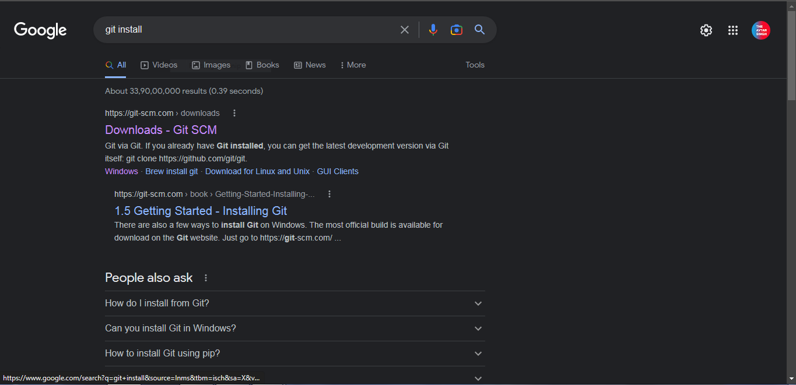

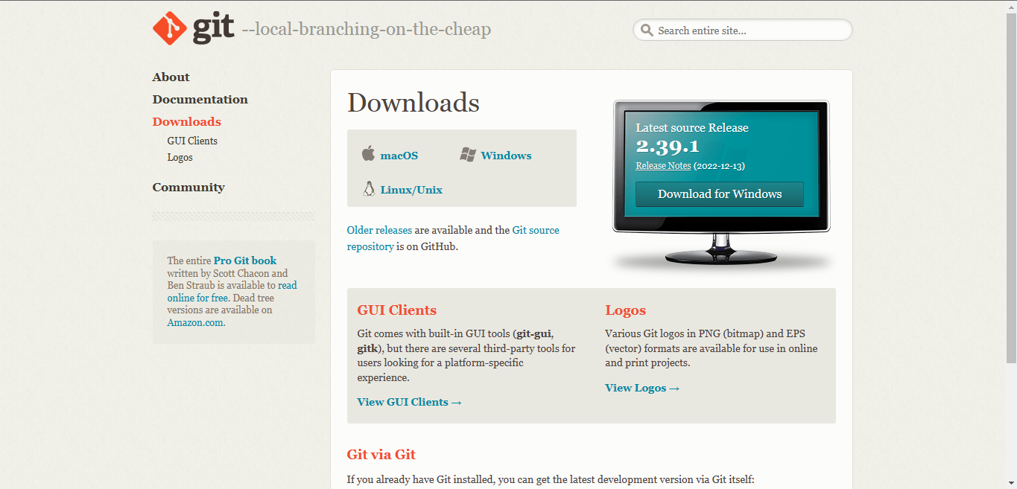

Gitbash

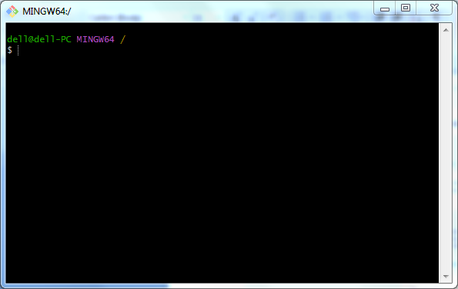

Github.com - Account Creation !

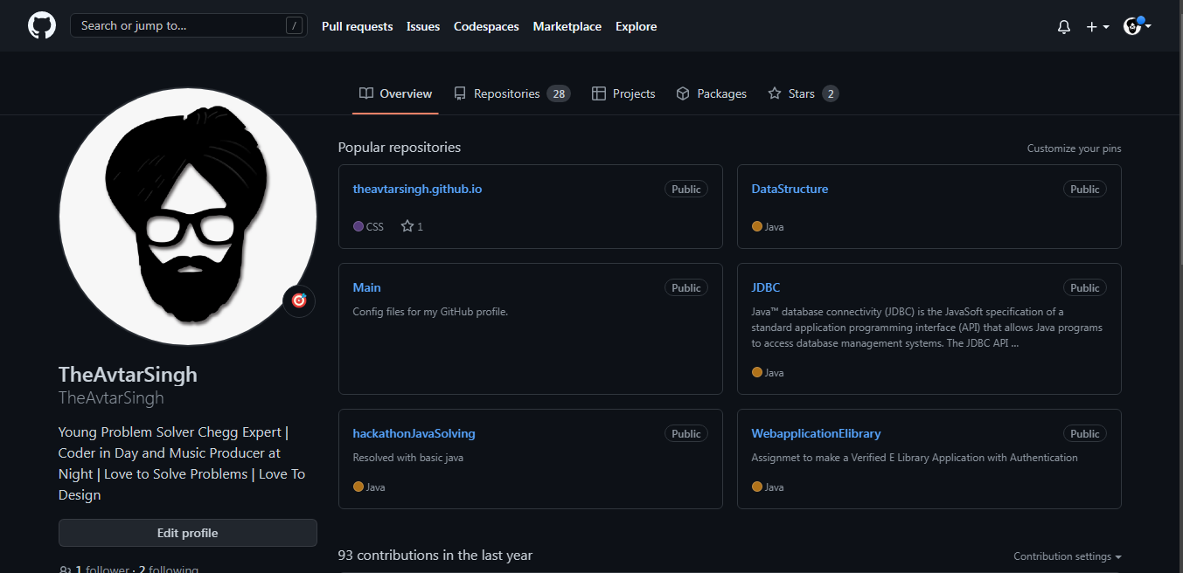

**Marks Obtained --------------------**

**Maximum Marks-----------------------------**

**Experiment No: 2**

Student Name and Roll Number: Avtar Singh / 20csu241

Semester /Section: 6th / FSB

Link to Code:

Date : 17/01/2023

Faculty Signature:

Remarks:

**Objective:** To create a file on the local git machine and push that file onto the global git repository.

**Student Work Area**

Setting Global UserName and UserEmail

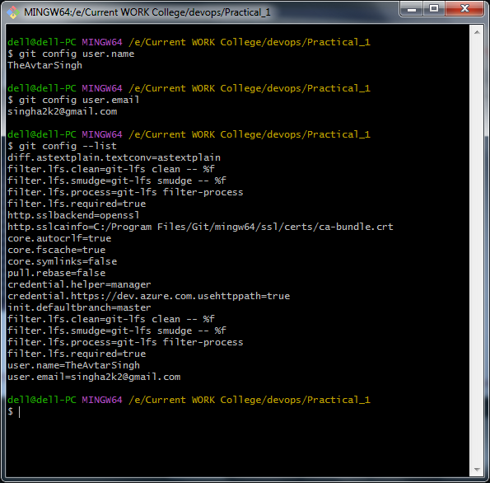

Creating Files and Sending to Staging Area

Uploading to Local Repository

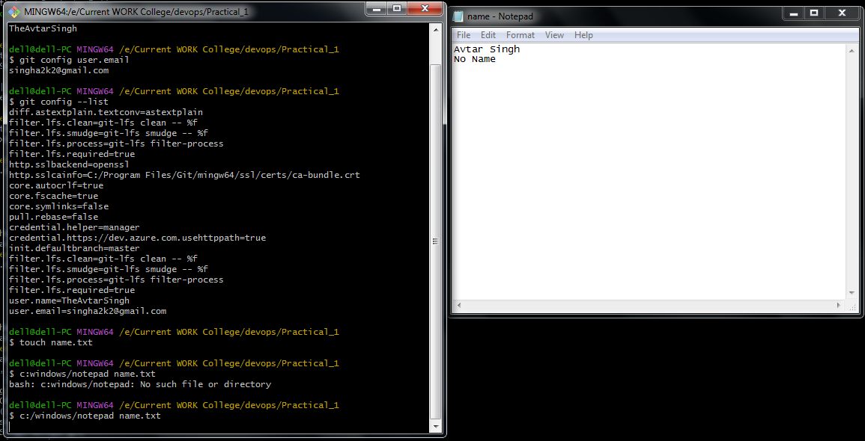

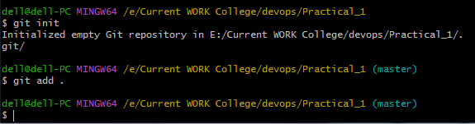

Commiting Files

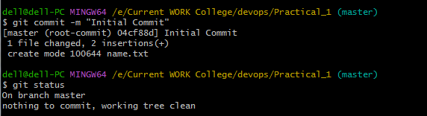

Pushing to Global Repository

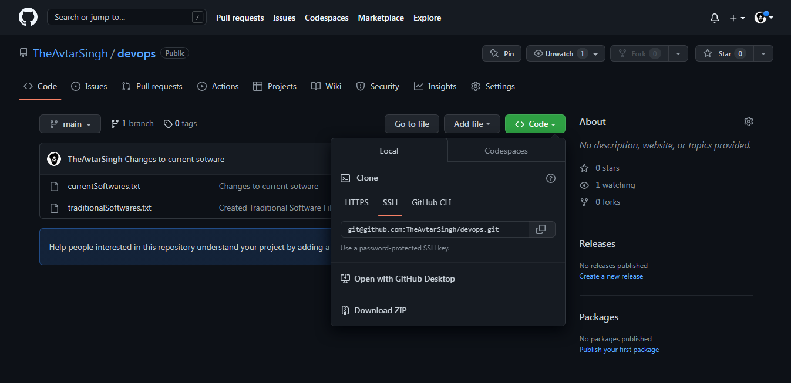

Adding Remote Origin

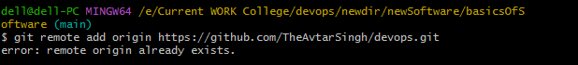

Checking Origin

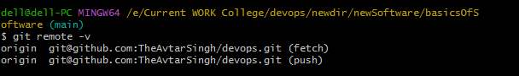

Setting SSH Key and Pushing to Github Main Origin

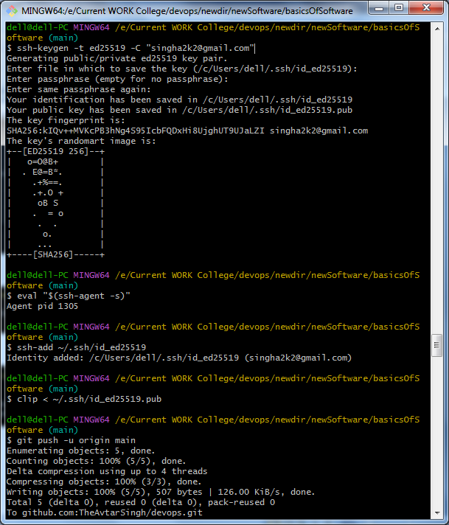

Pulling Files From Global to local Repository

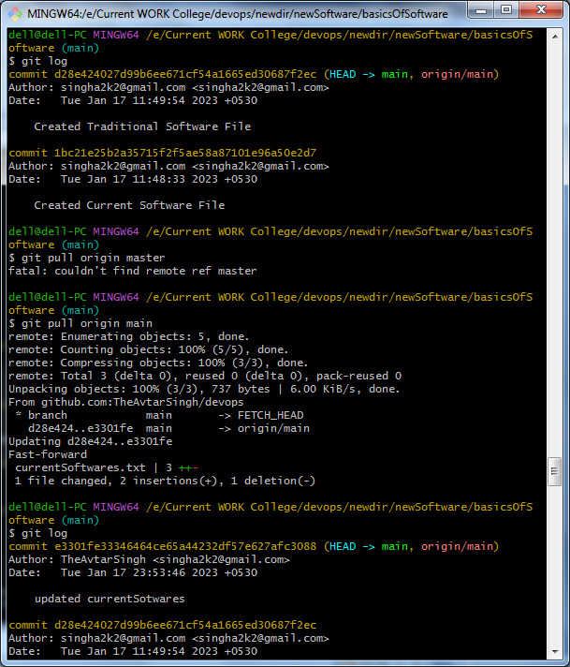

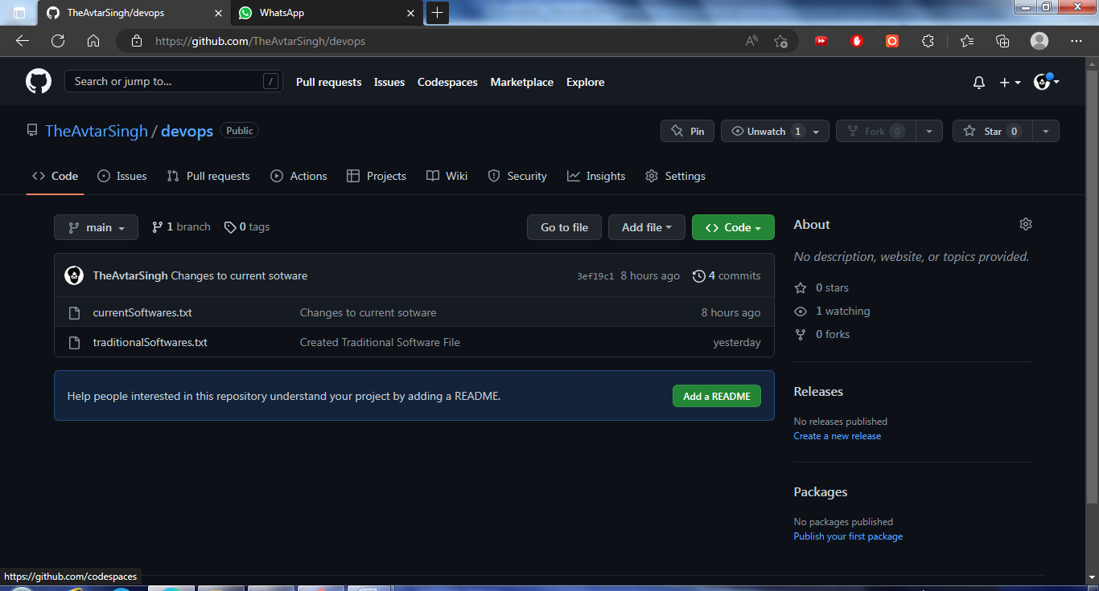

**Marks Obtained -------------------------**

**Maximum Marks-----------------------------**

**Experiment No: 3**

Student Name and Roll Number: Avtar Singh / 20csu241

Semester /Section: 6th / FSB

Link to Code:

Date: 24/01/2023

Faculty Signature:

Remarks:

**Objective:** Creation of Branches, Merging the Files

**Student Work Area**

Creating files

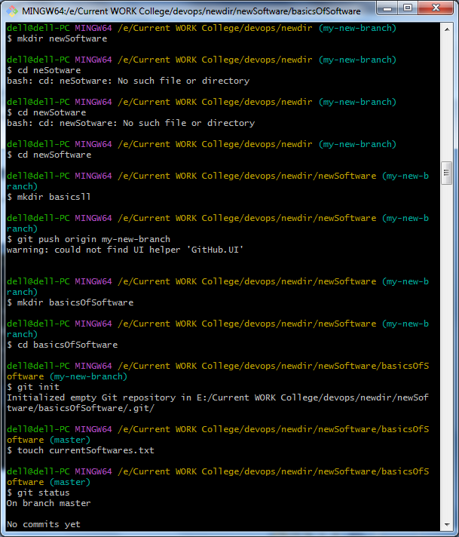

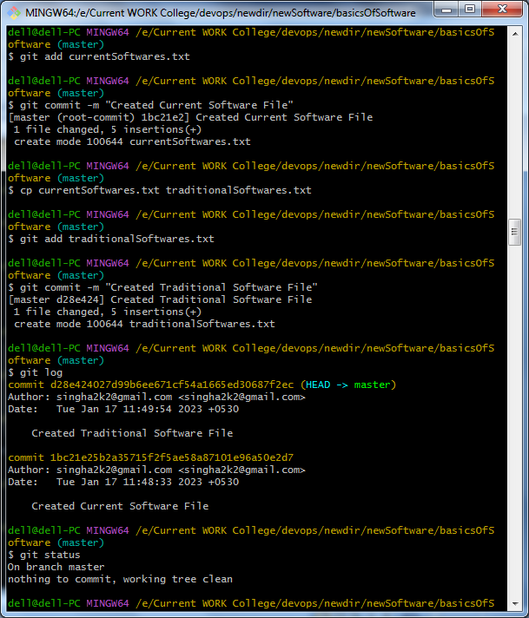

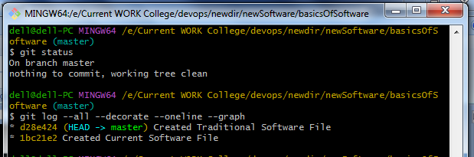

Creating Branches

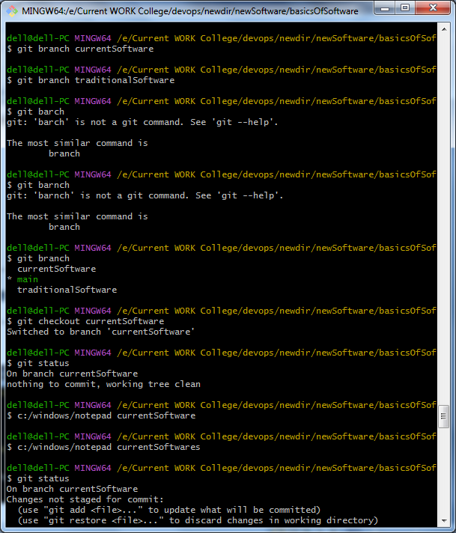

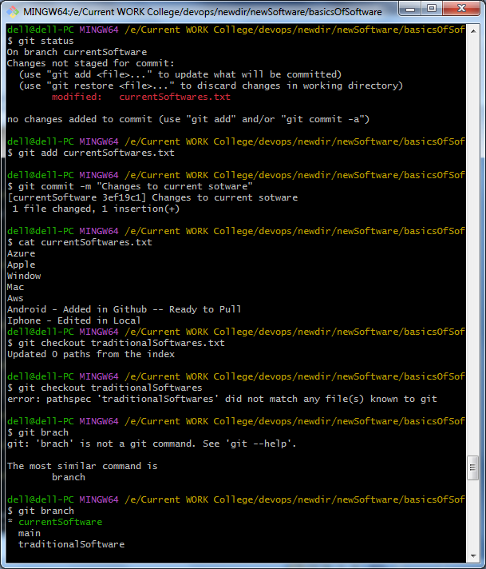

Editing in File and Merging Branch

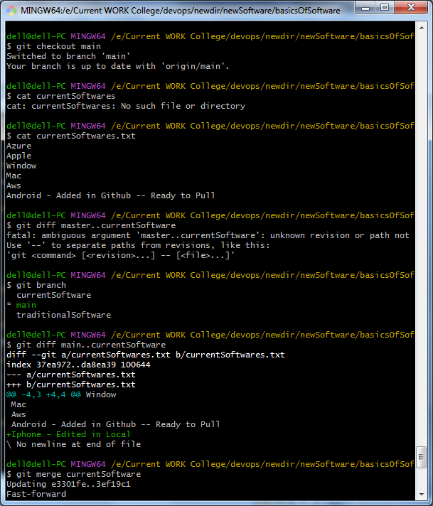

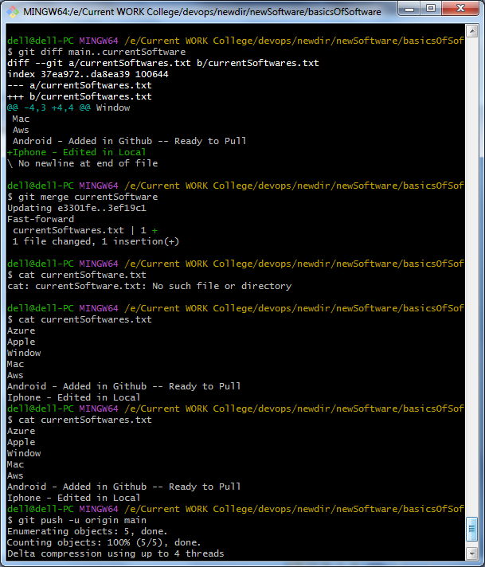

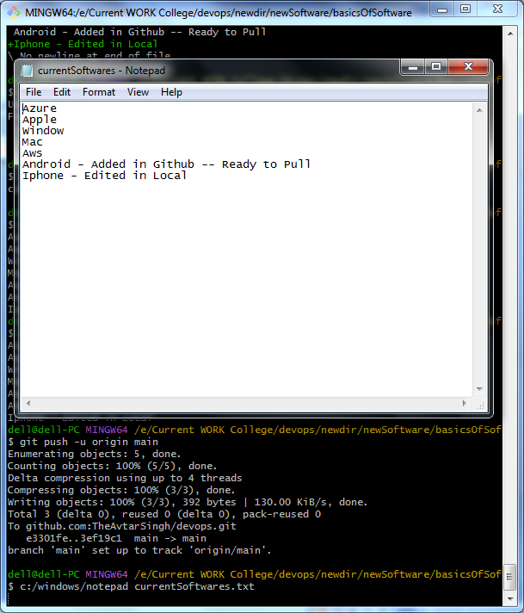

git log --oneline

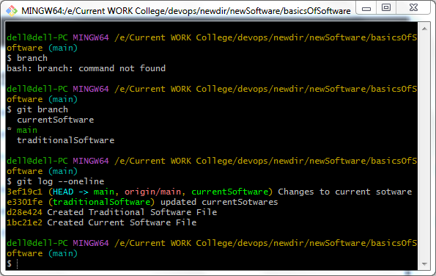

**Marks Obtained -------------------------**

**Maximum Marks-----------------------------**

**Experiment No: 4**

Student Name and Roll Number: Avtar Singh / 20csu241

Semester /Section: 6th / FSB

Link to Code:

Date: 24/01/2023

Faculty Signature:

Remarks:

**Objective: C**reate a shopping master branch and then create two branched product1 and product2 and two more user registration and product details. Create diff text files and then merge into one

**Student Work Area**

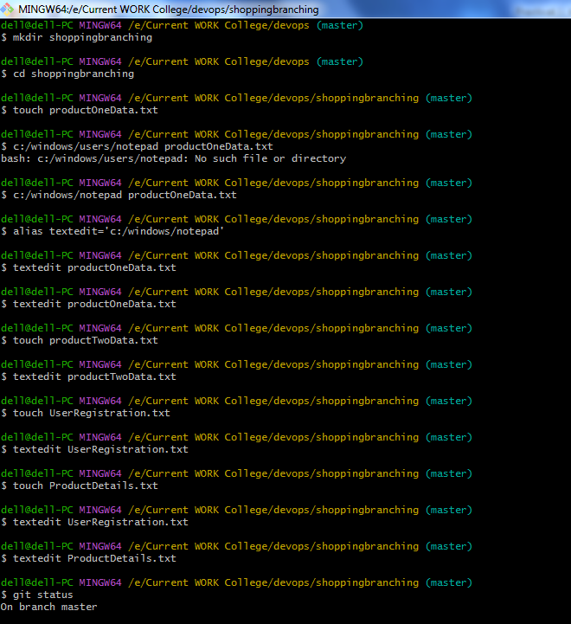

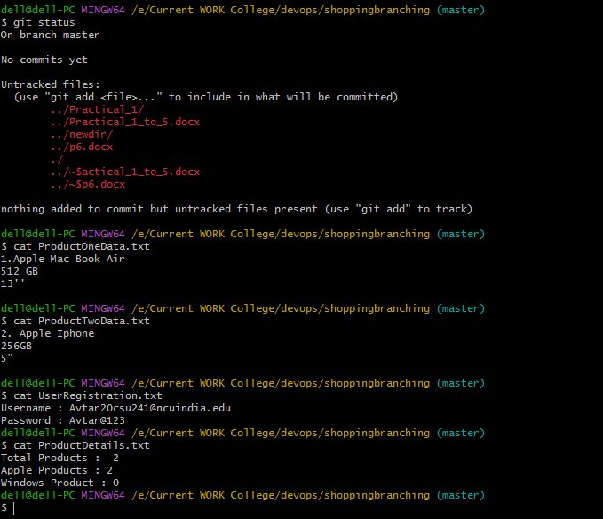 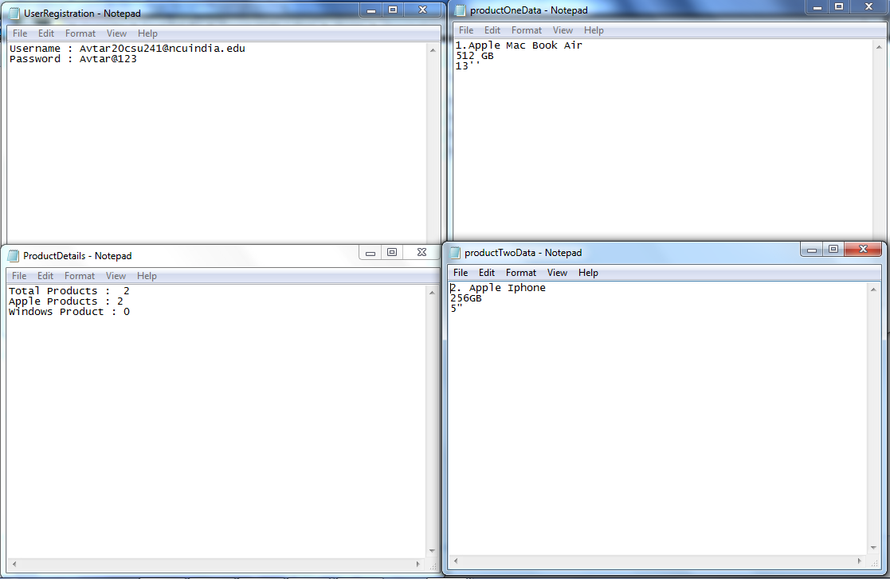

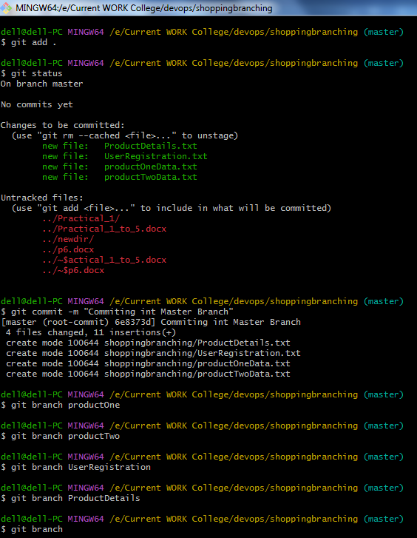

Modifying Data and Commiting in One Branch

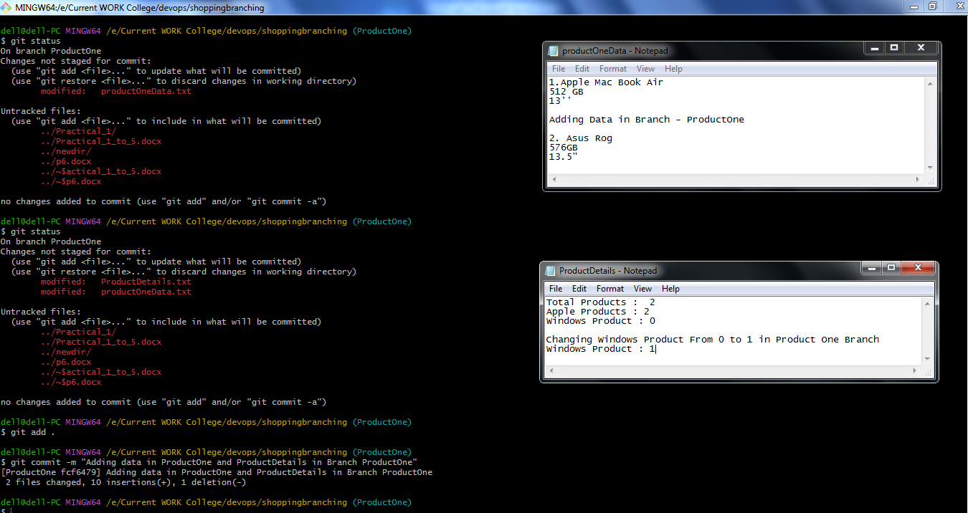

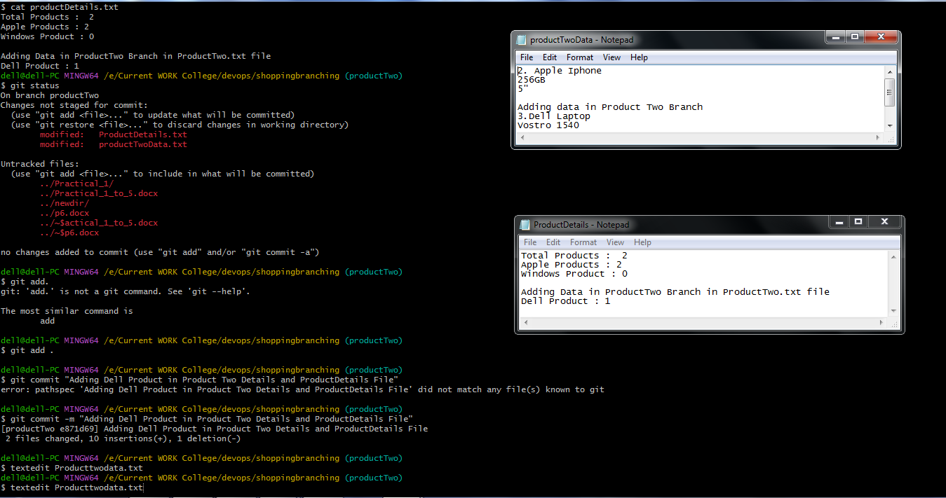

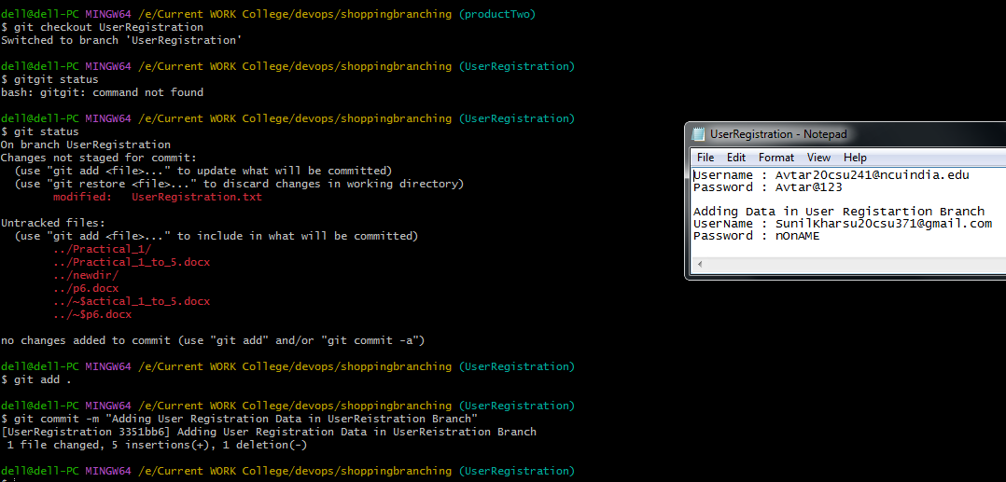

Merging Branch

Getting Differences

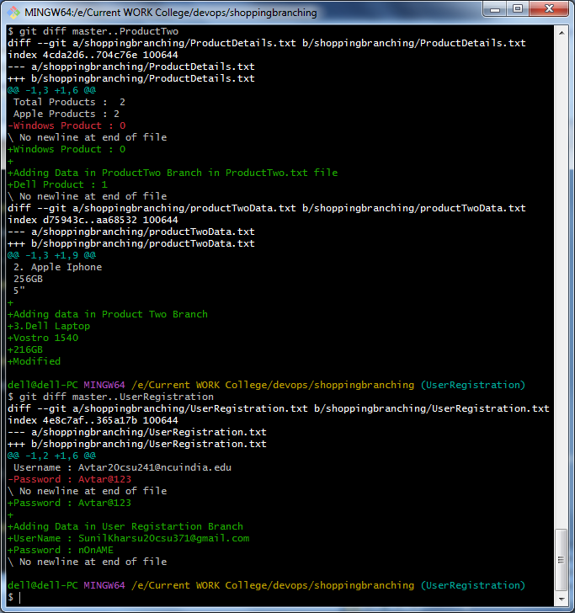

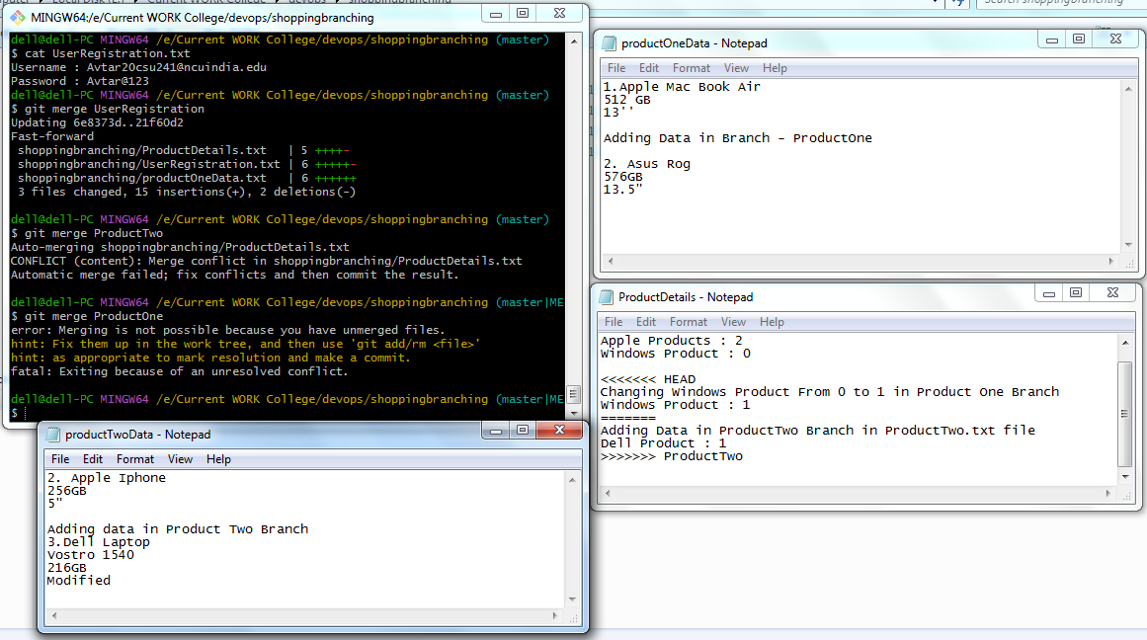

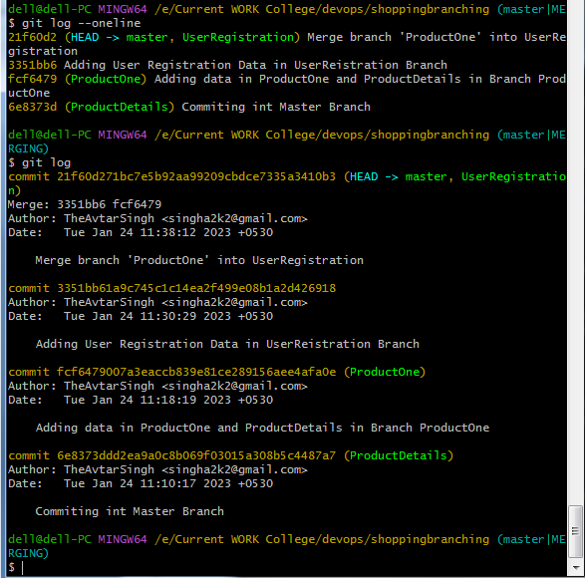

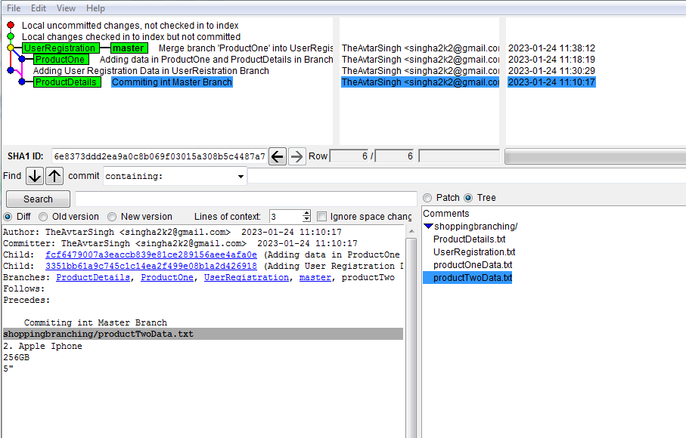

**Marks Obtained ------------------------**

**Maximum Marks-----------------------------**

**Experiment No: 5**

Student Name and Roll Number: Avtar Singh / 20csu241

Semester /Section: 6th / FSB

Link to Code:

Date: 25/01/2023

Faculty Signature:

Remarks:

**Objective:** Show Git Merge Conflict .

**Student Work Area**

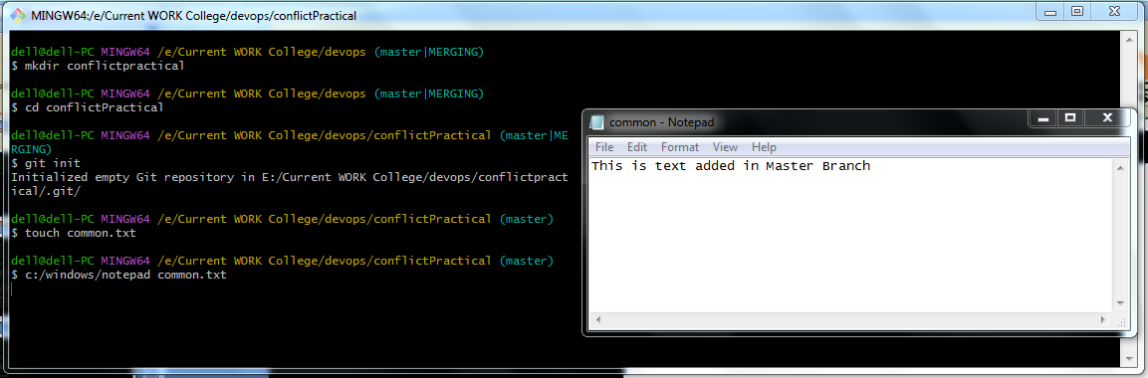

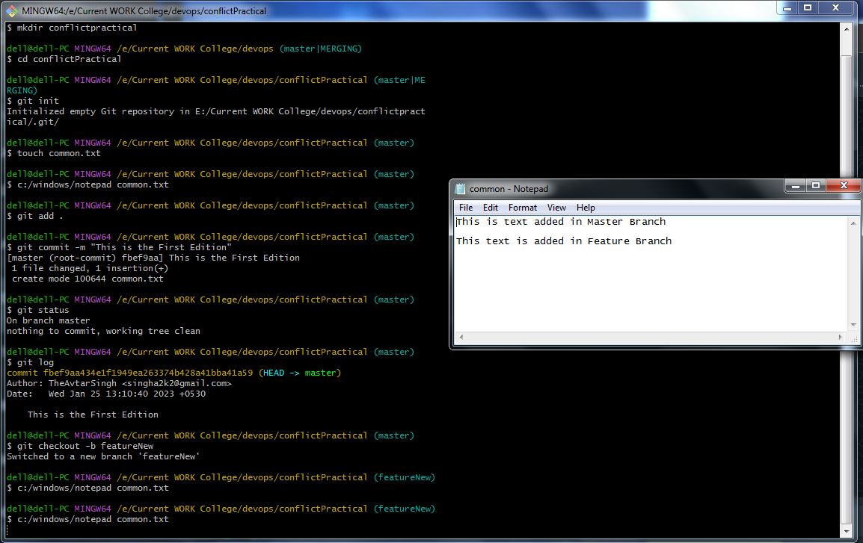

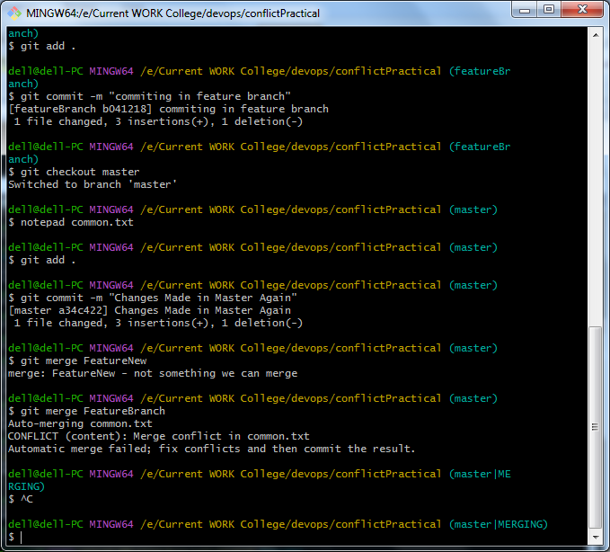

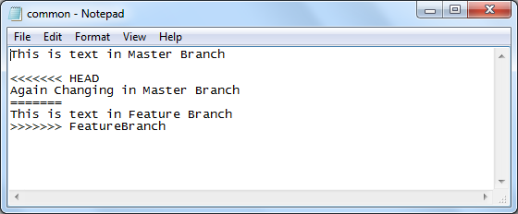

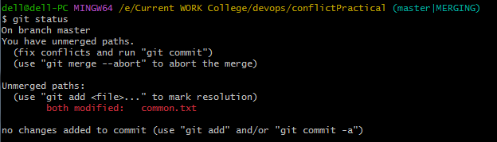

**Marks Obtained -------------------------**

**Maximum Marks----------------------------**

**Experiment No: 6**

Student Name and Roll Number: Avtar Singh / 20csu241

Semester /Section: 6th / FSB

Link to Code:

Date: 25/01/2023

Faculty Signature:

Remarks:

**Objective:** Solve Git Merging Conflicts.

**Student Work Area**

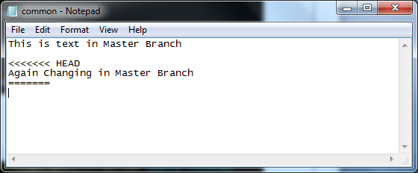

Deleting unused Content and merging

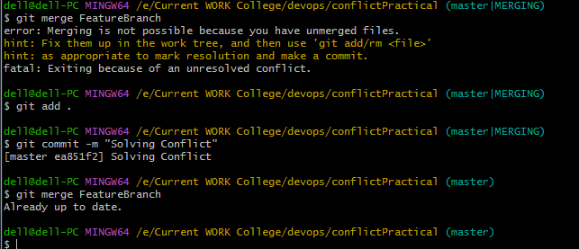

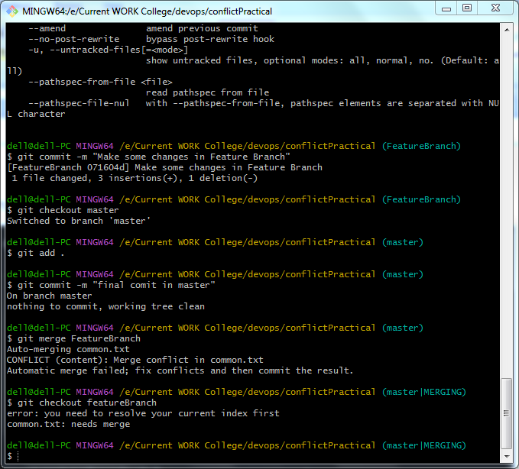

**Marks Obtained -------------------------**

**Maximum Marks-----------------------------**

**Experiment No: 7**

Student Name and Roll Number: Avtar Singh / 20csu241

Semester /Section: 6th / FSB

Link to Code:

Date: 31/01/2023

Faculty Signature:

Remarks:

**Objective:** Show Git Stashing and Use it.

**Student Work Area**

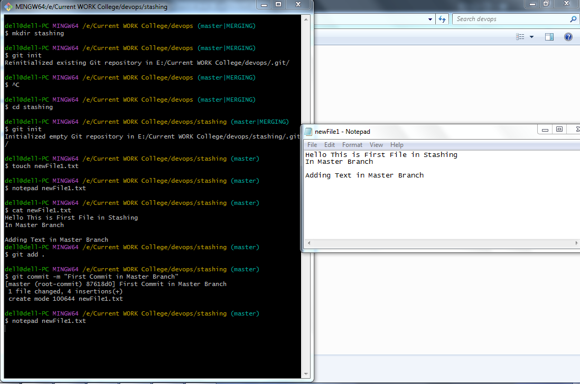

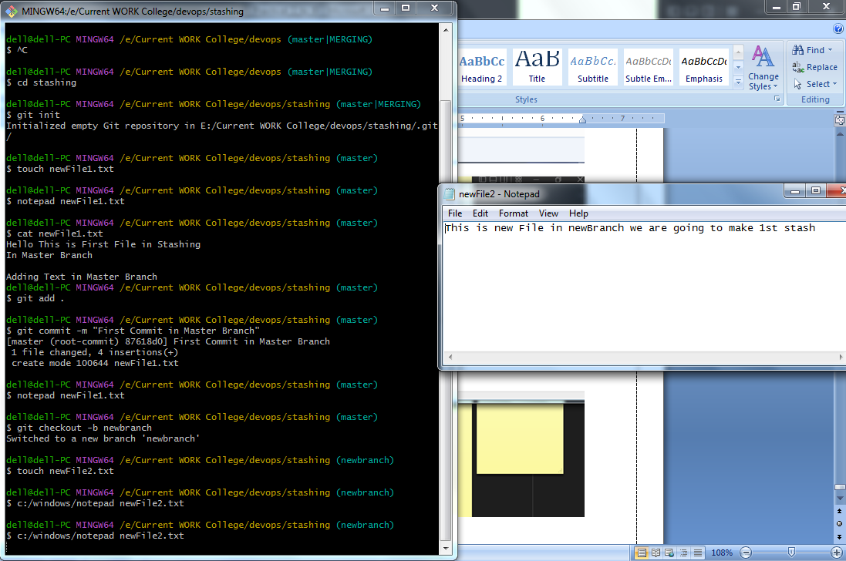

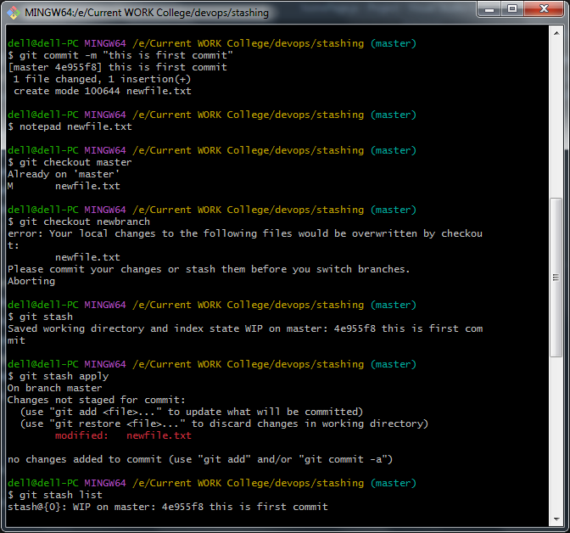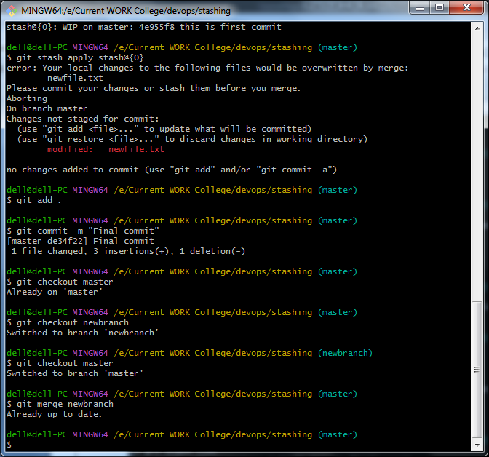

**Marks Obtained -------------------------**

**Maximum Marks-----------------------------**

**Experiment No: 8**

Student Name and Roll Number: Avtar Singh / 20csu241

Semester /Section: 6th / FSB

Link to Code:

Date:01/02/2023

Faculty Signature:

Remarks:

**Objective:** Create 3 features for an auto mobile master project

1. Electronic Utilities

2. Electronic engine

3. Hybrid Details

create 3 text documents and show the git stashing for the same..

**Student Work Area**

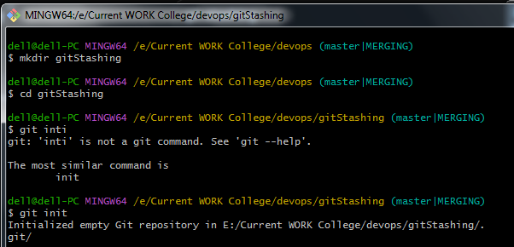

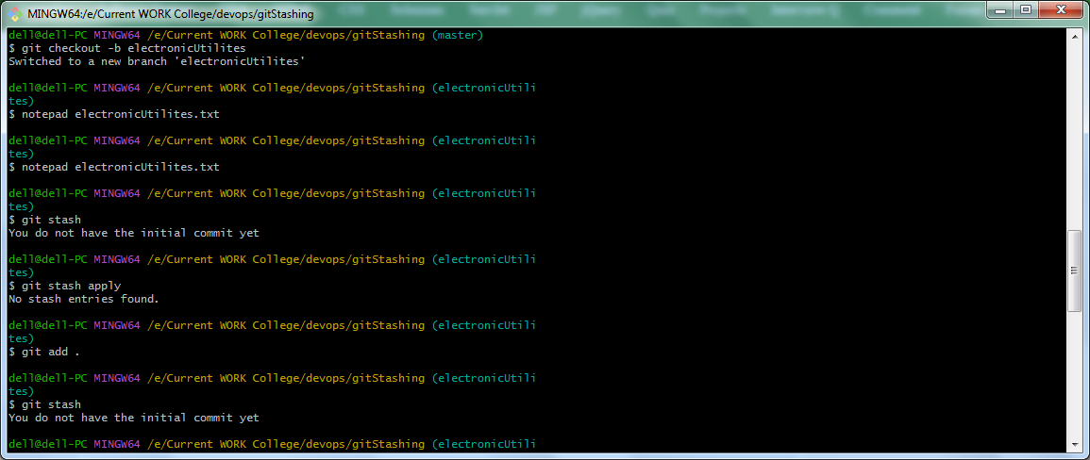

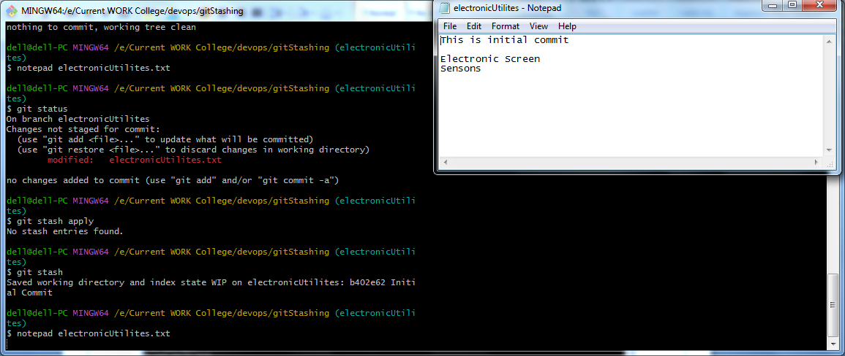



Restoring Stash

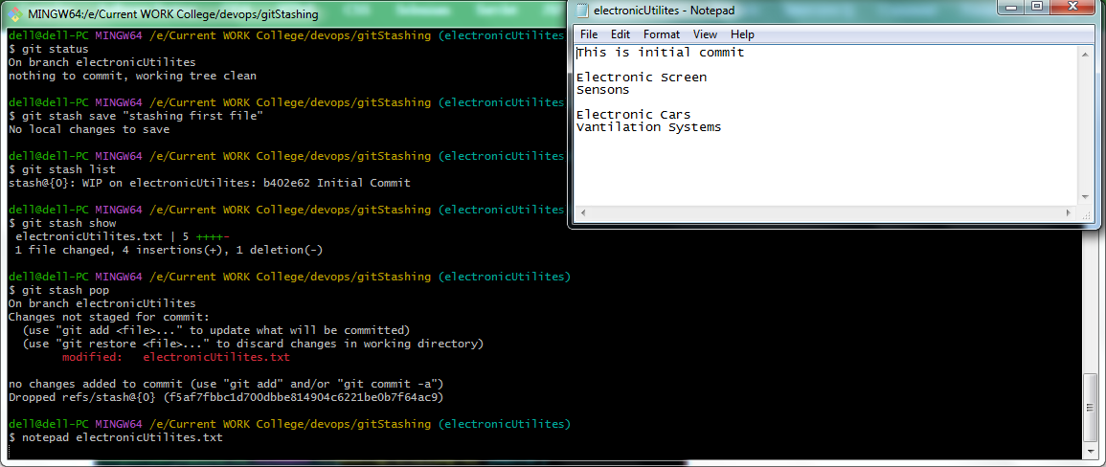

2nd Feature :

Adding Content in File and Creating a Stash

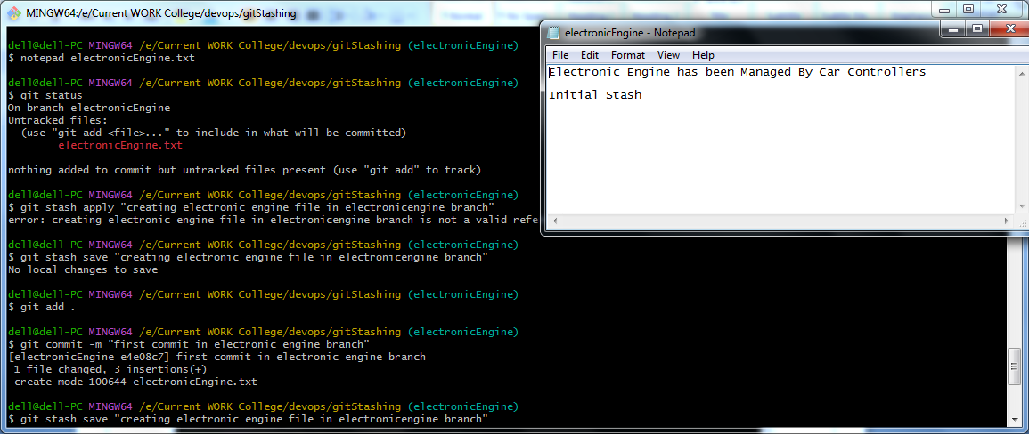

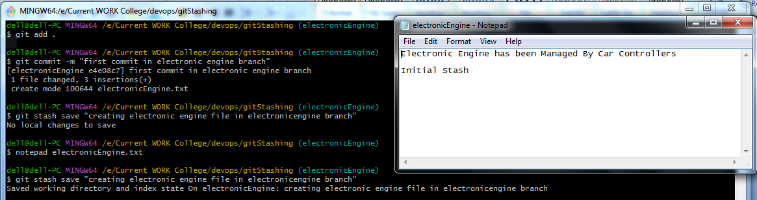

Similarly for Feature 3

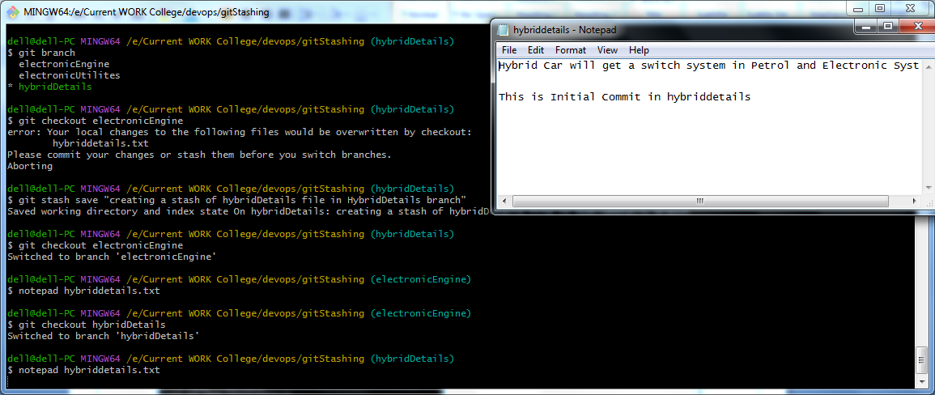

All Stashes

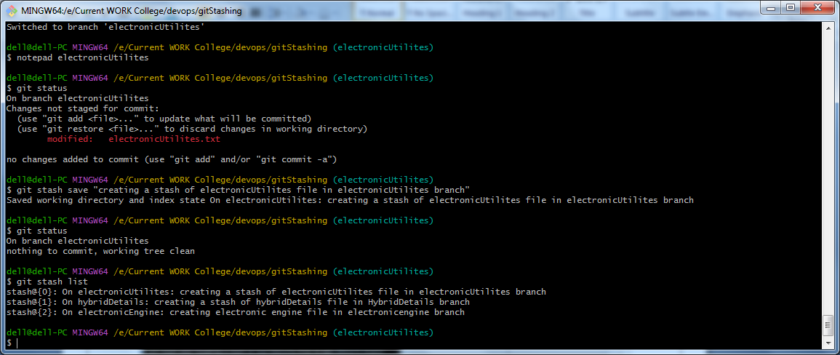

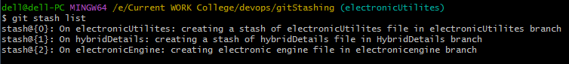

Invoking git Stashes :

using git stash pop

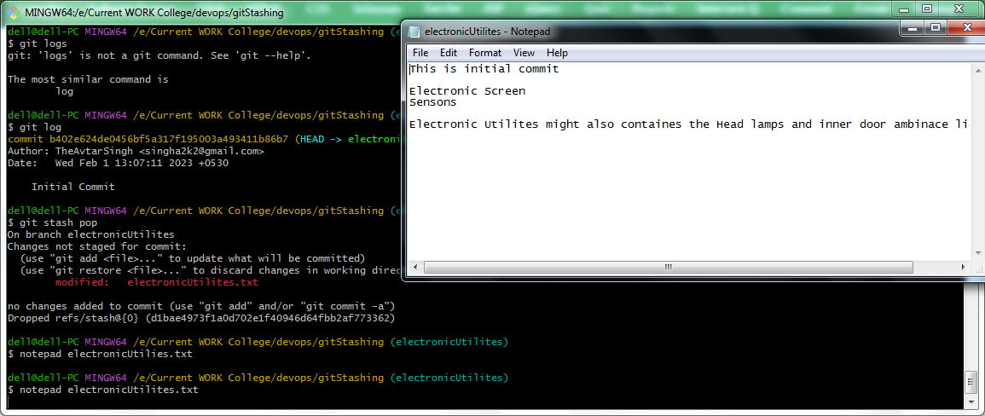

And Commiting the File

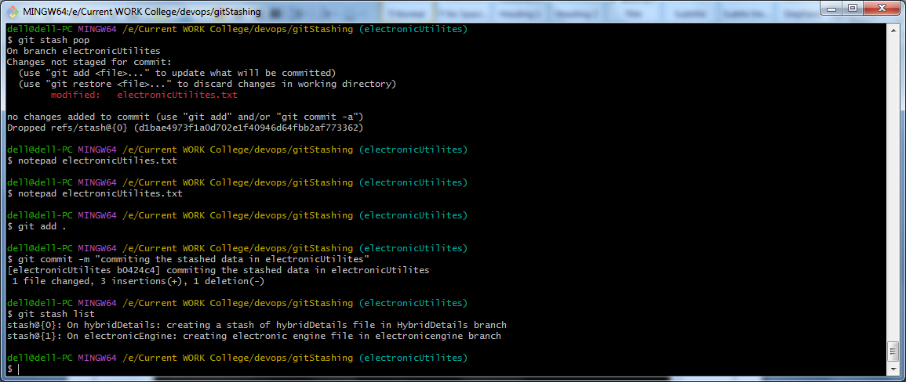

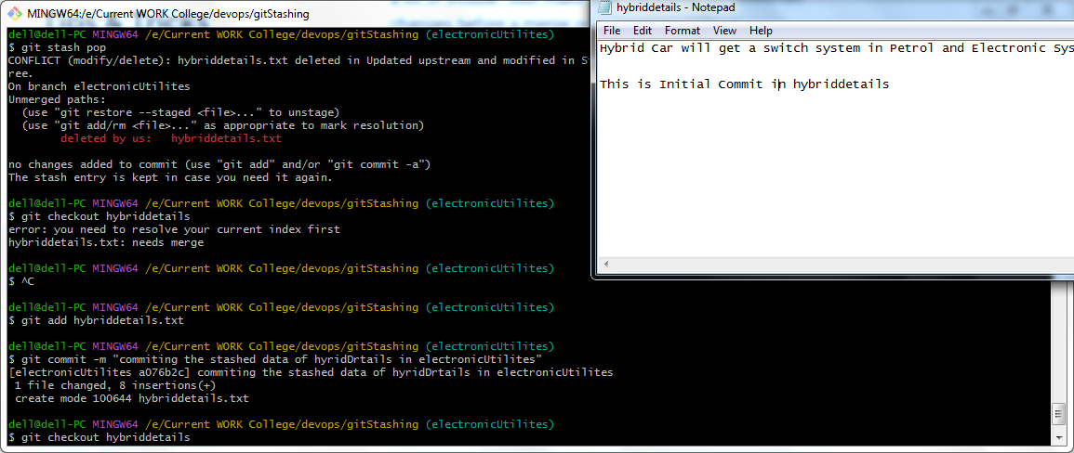

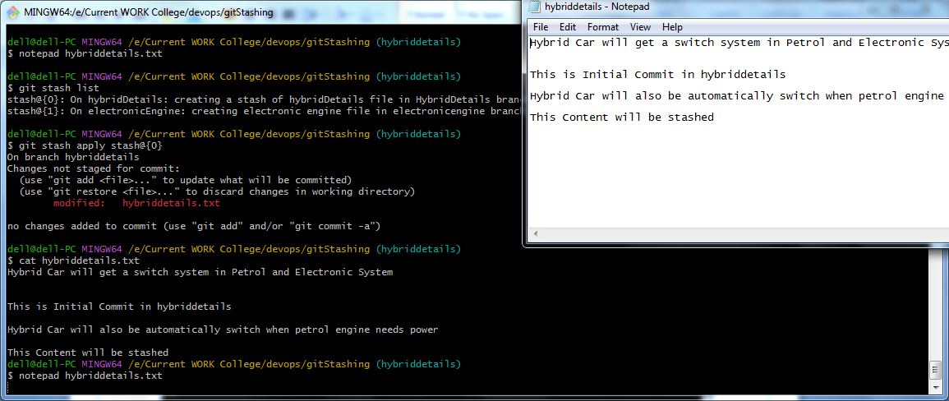

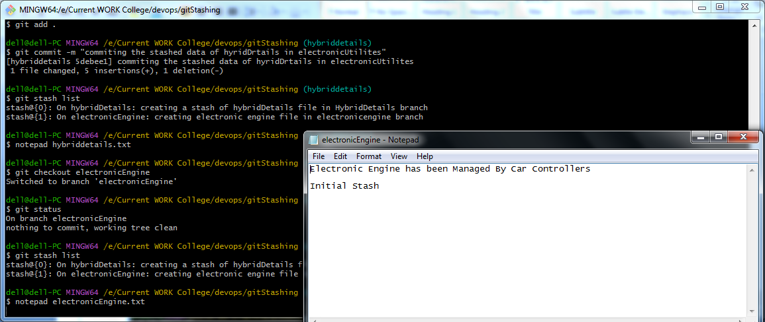 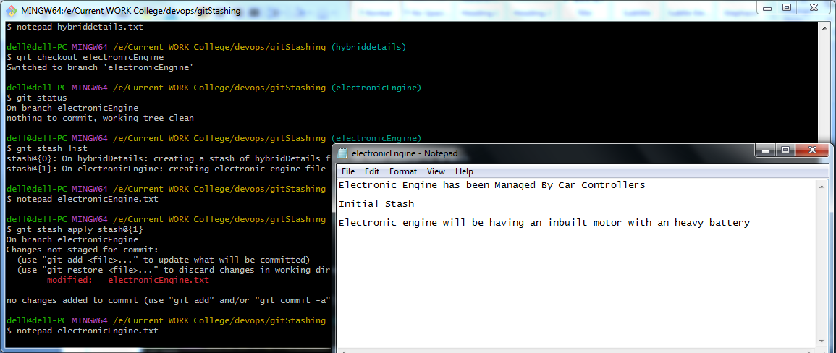

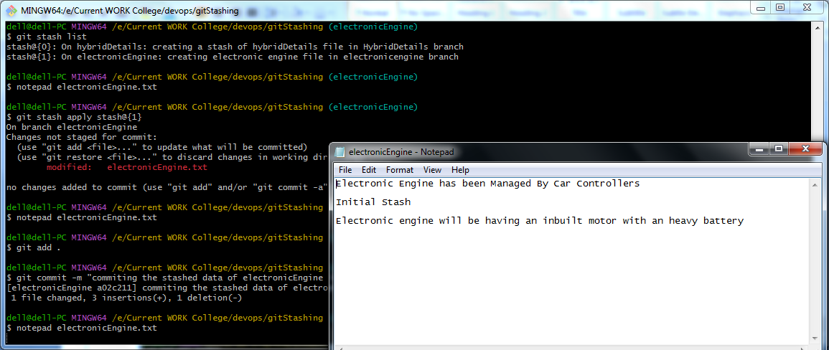

Dropping Stashes

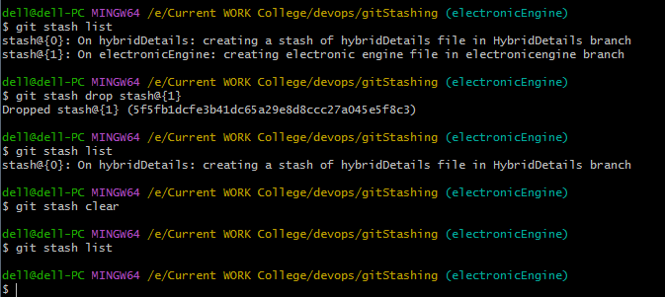

Merging Branches :

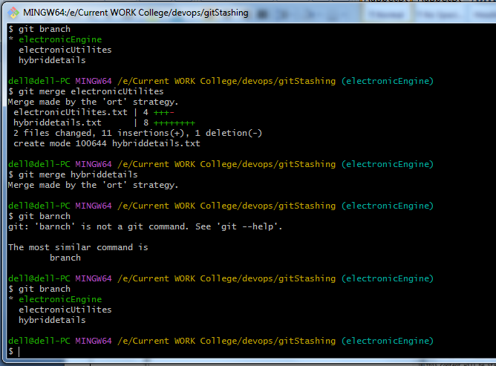

Final Result

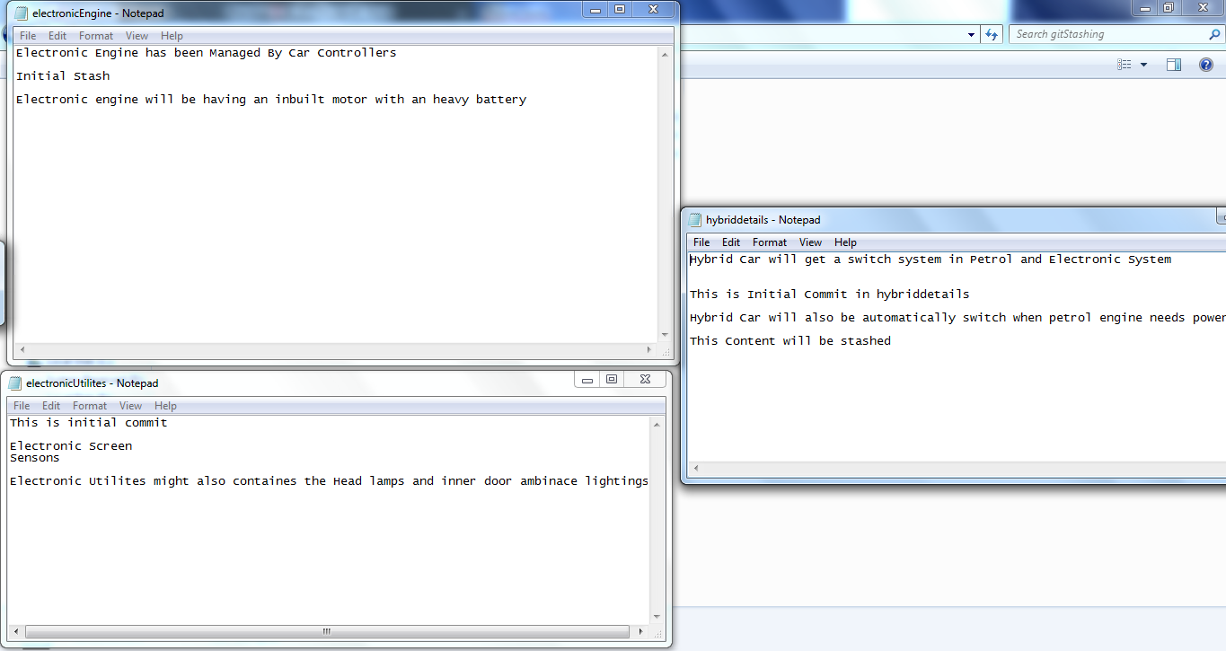

**Marks Obtained -------------------------**

**Maximum Marks-----------------------**

**Experiment No: 9**

Student Name and Roll Number: Avtar Singh / 20csu241

Semester /Section: 6th / FSB

Link to Code:

Date: 07/02/2023

Faculty Signature:

Remarks:

**Objective:** Use Git Rebase.

**Student Work Area**

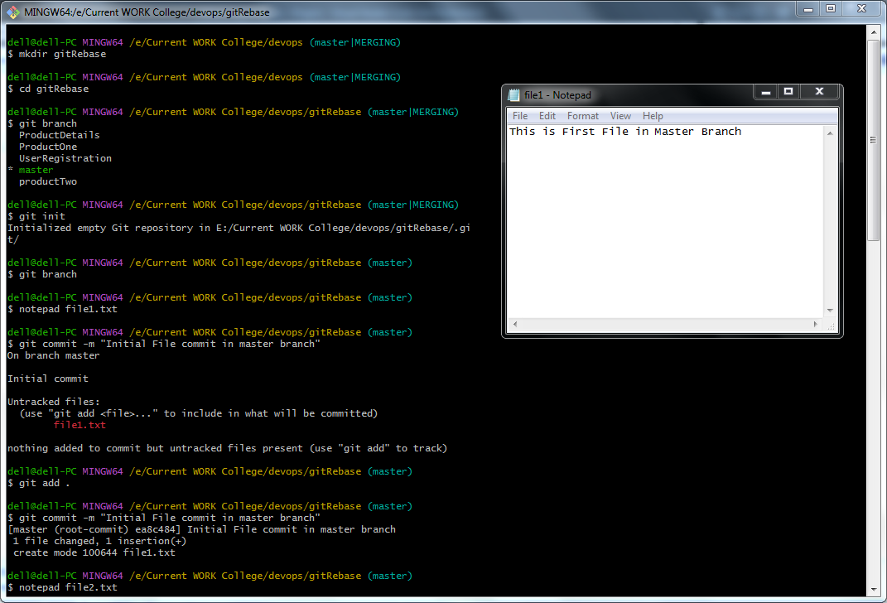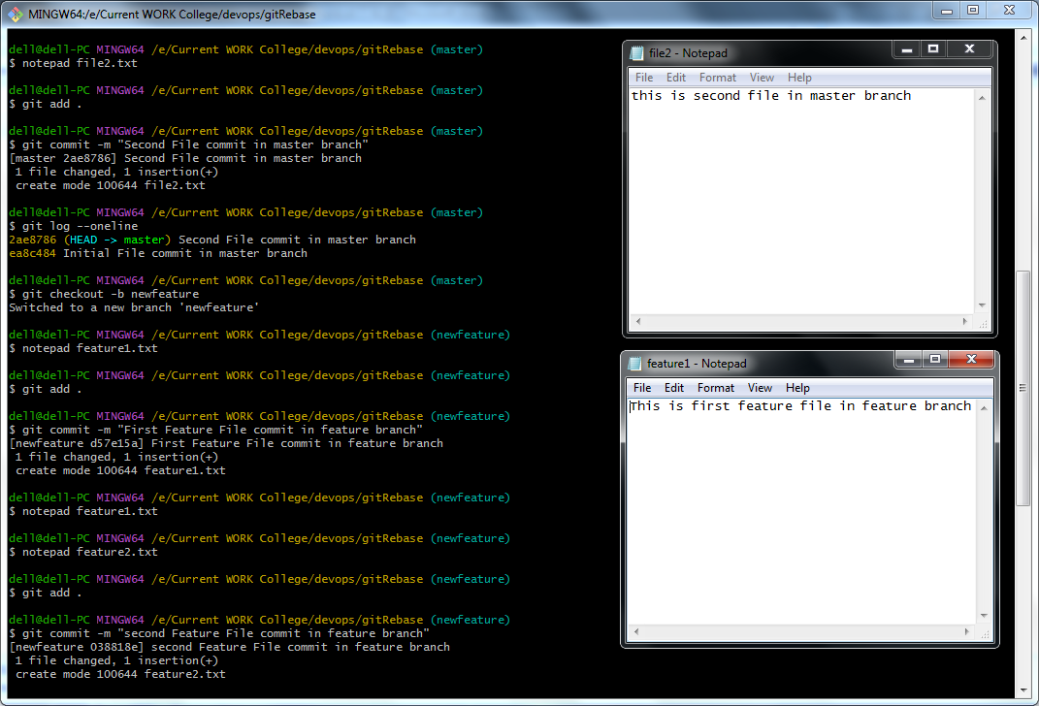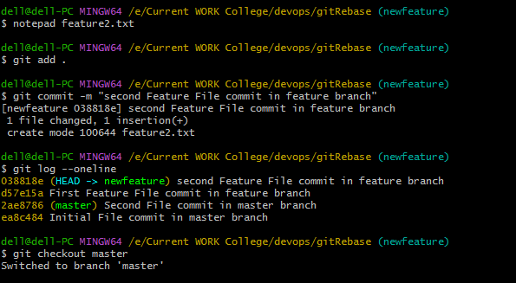

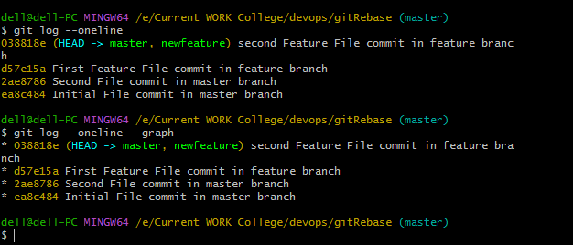

Merge (Vs)

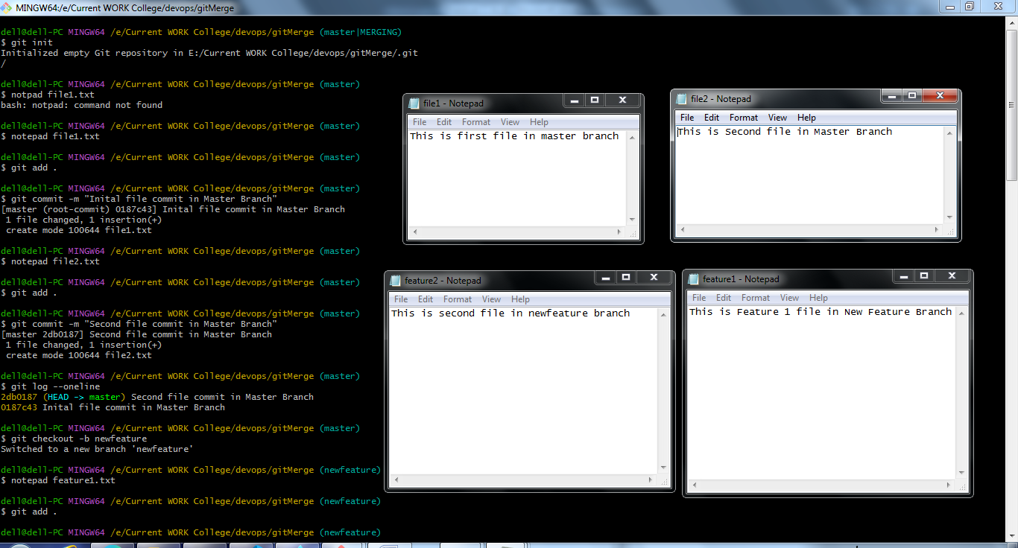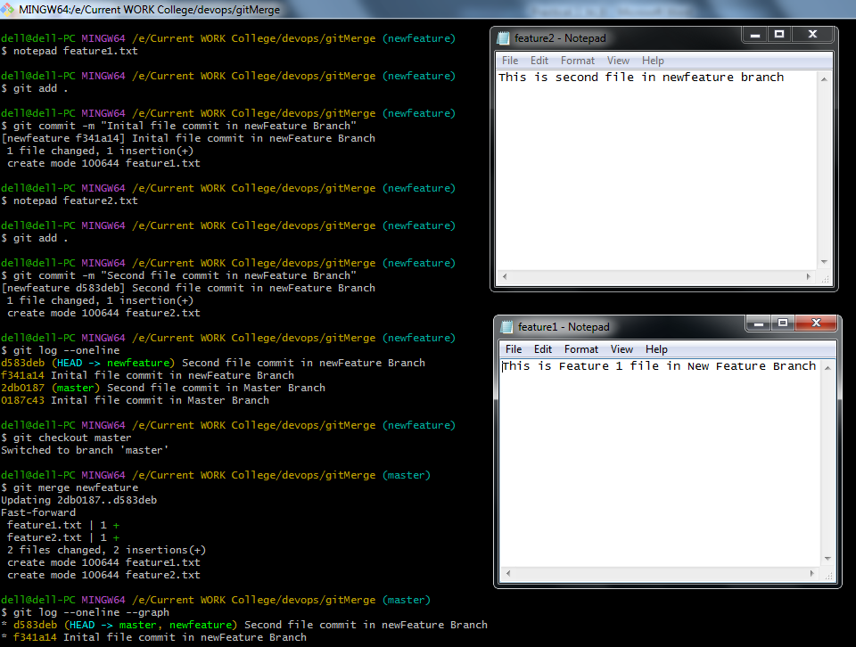

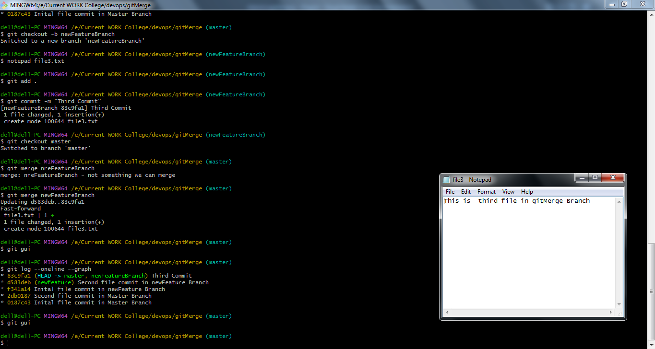

GUI Difference

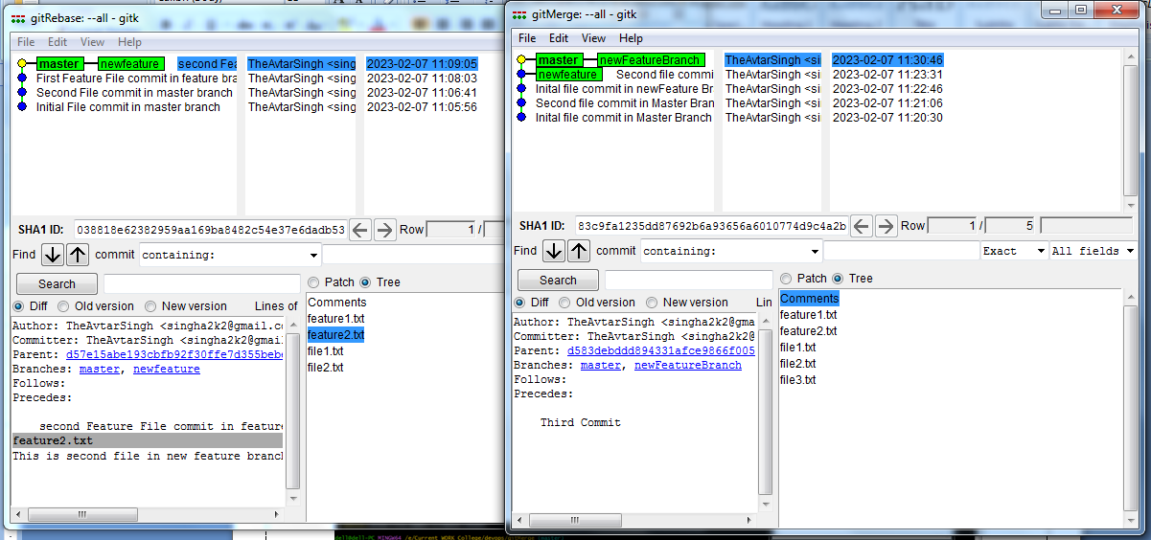

**Marks Obtained -------------------------**

**Maximum Marks-----------------------**

**Experiment No: 10**

Student Name and Roll Number: Avtar Singh / 20csu241

Semester /Section: 6th / FSB

Link to Code:

Date: 14/02/2023

Faculty Signature:

Remarks:

**Objective:** Install and Configure Jenkins.

**Student Work Area**

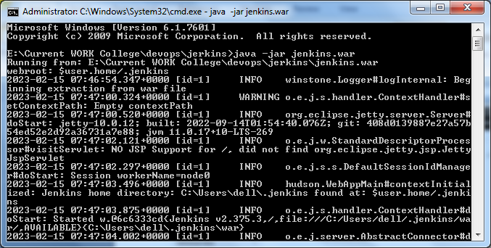

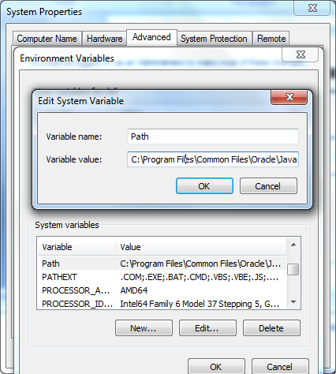

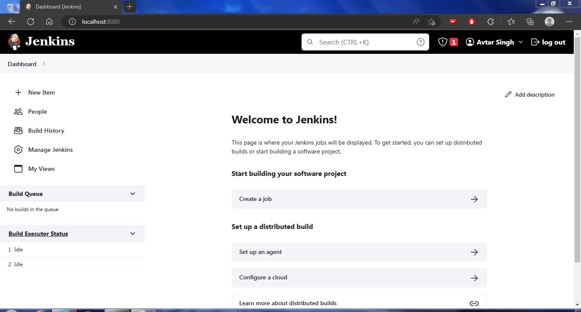

**Marks Obtained -------------------------**

**Maximum Marks------------------------**

**Experiment No: 11**

Student Name and Roll Number: Avtar Singh / 20csu241

Semester /Section: 6th / FSB

Link to Code:

Date: 15/02/2023

Faculty Signature:

Remarks:

**Objective:** Build First Job in Jenkins.

**Student Work Area**

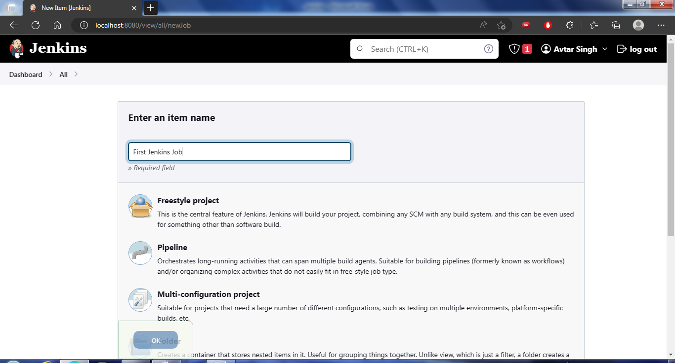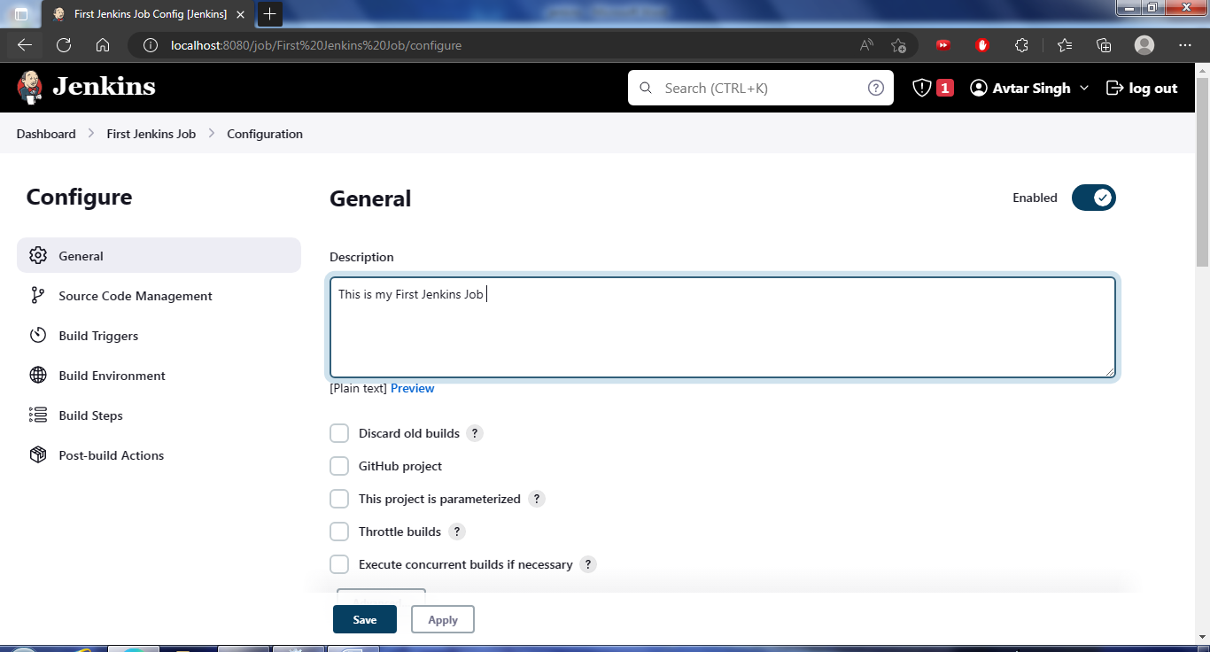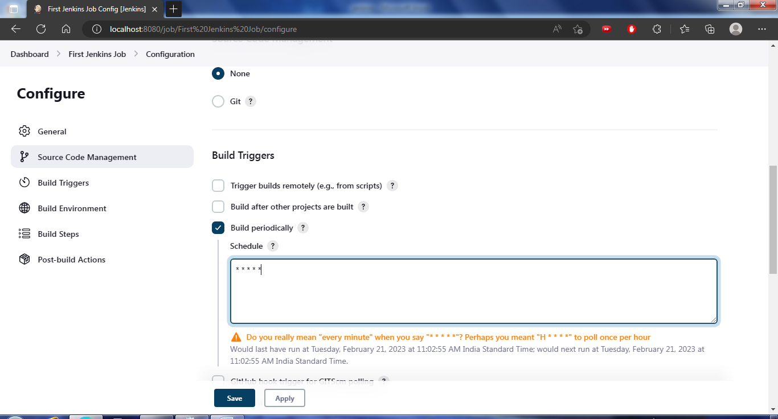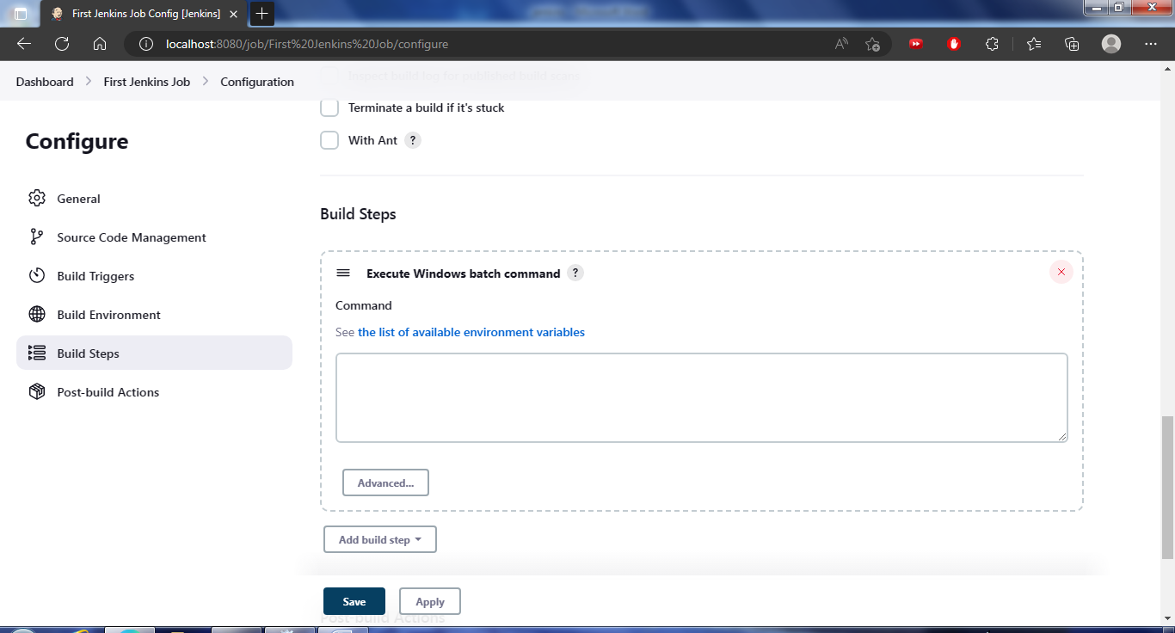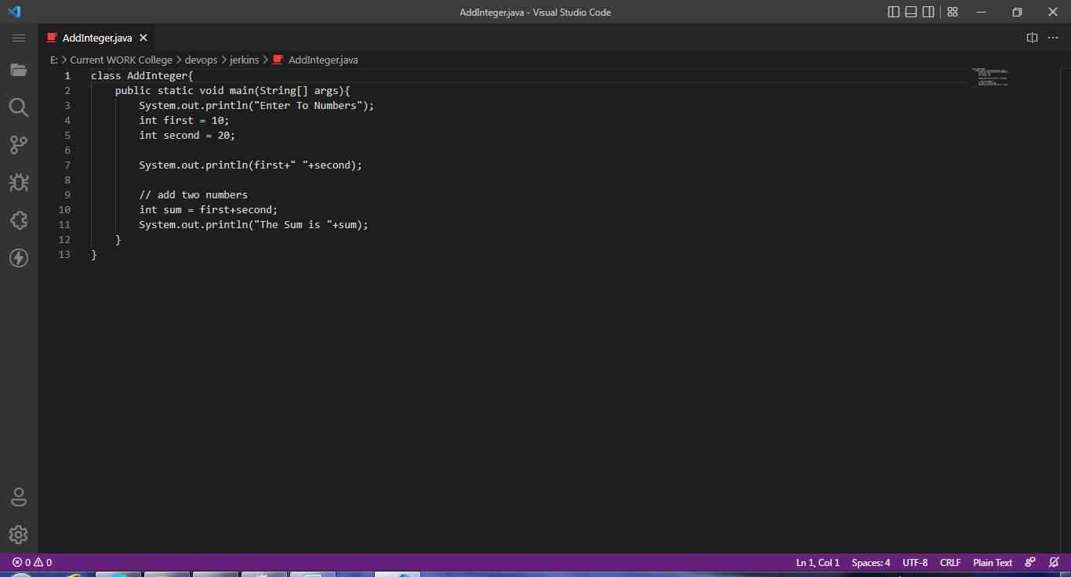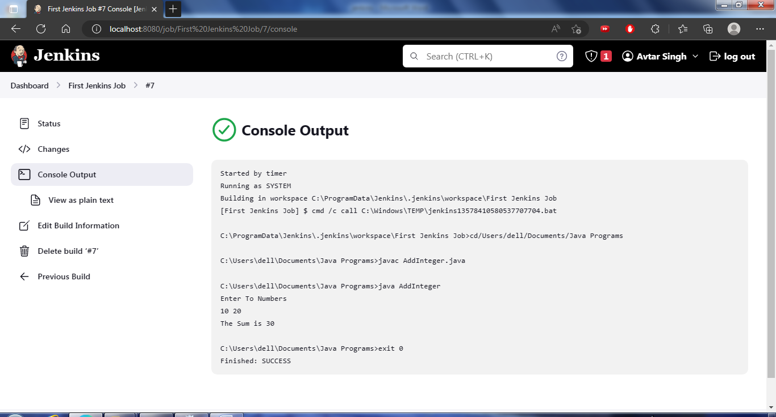

**Marks Obtained -------------------------**

**Maximum Marks------------------------**

**Experiment No: 12**

Student Name and Roll Number: Avtar Singh / 20csu241

Semester /Section: 6th / FSB

Link to Code:

Date: 21/02/2023

Faculty Signature:

Remarks:

**Objective:** Multiply Two Floating Numbers at duration of 1 hour.

**Student Work Area**

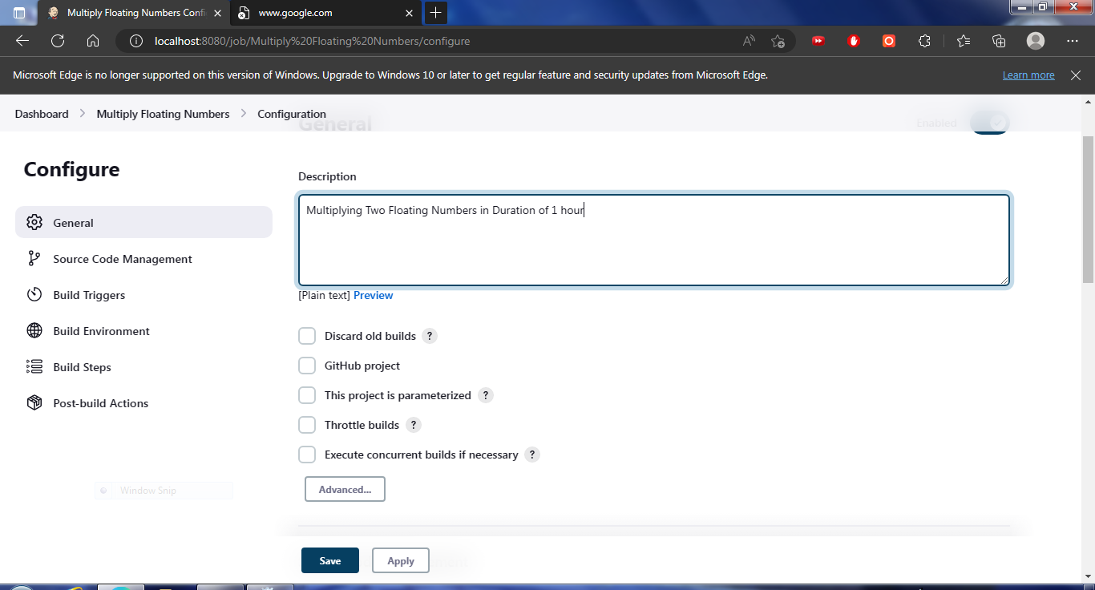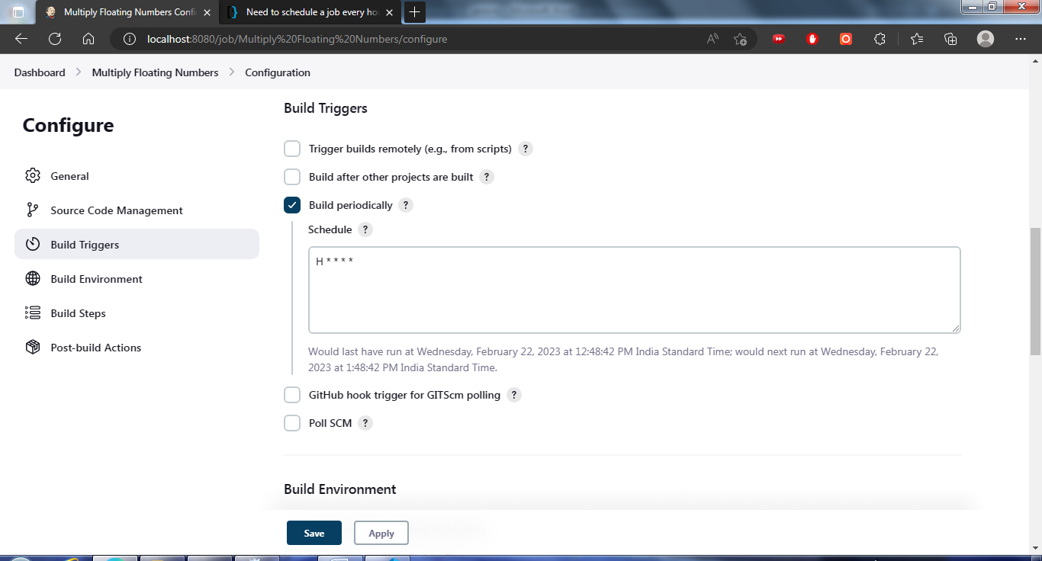

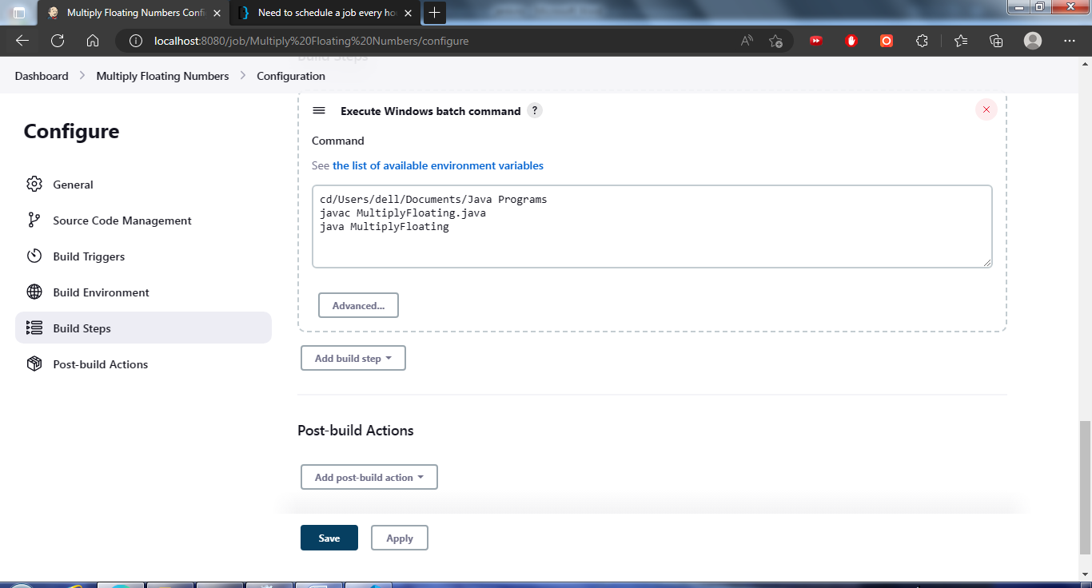

**Marks Obtained -------------------------**

**Maximum Marks------------------------**

**Experiment No: 13**

Student Name and Roll Number: Avtar Singh / 20csu241

Semester /Section: 6th / FSB

Link to Code:

Date: 22/02/2023

Faculty Signature:

Remarks:

**Objective:** Remote Trigger Jenkins Program.

**Student Work Area**

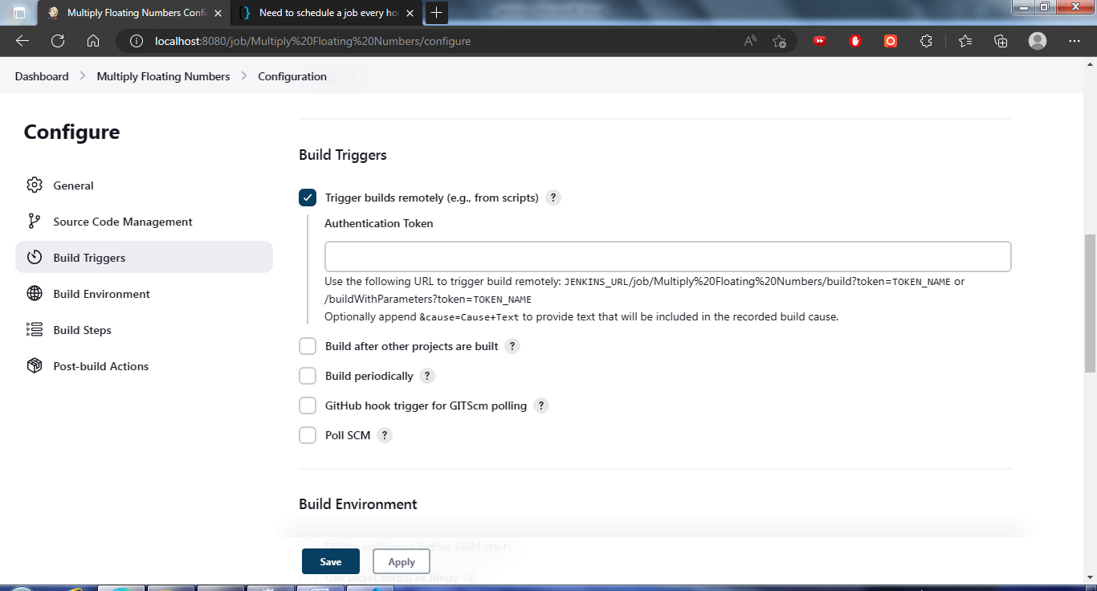

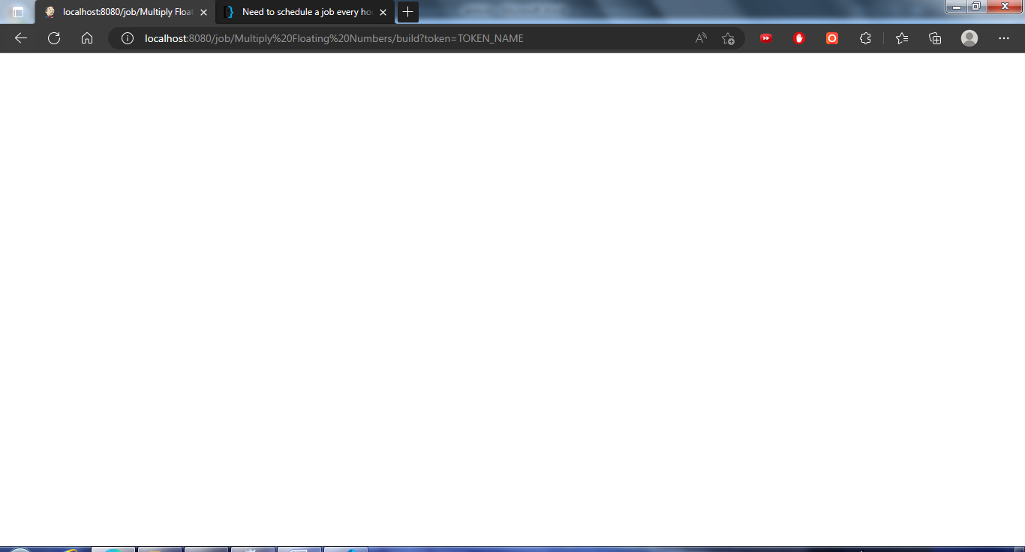

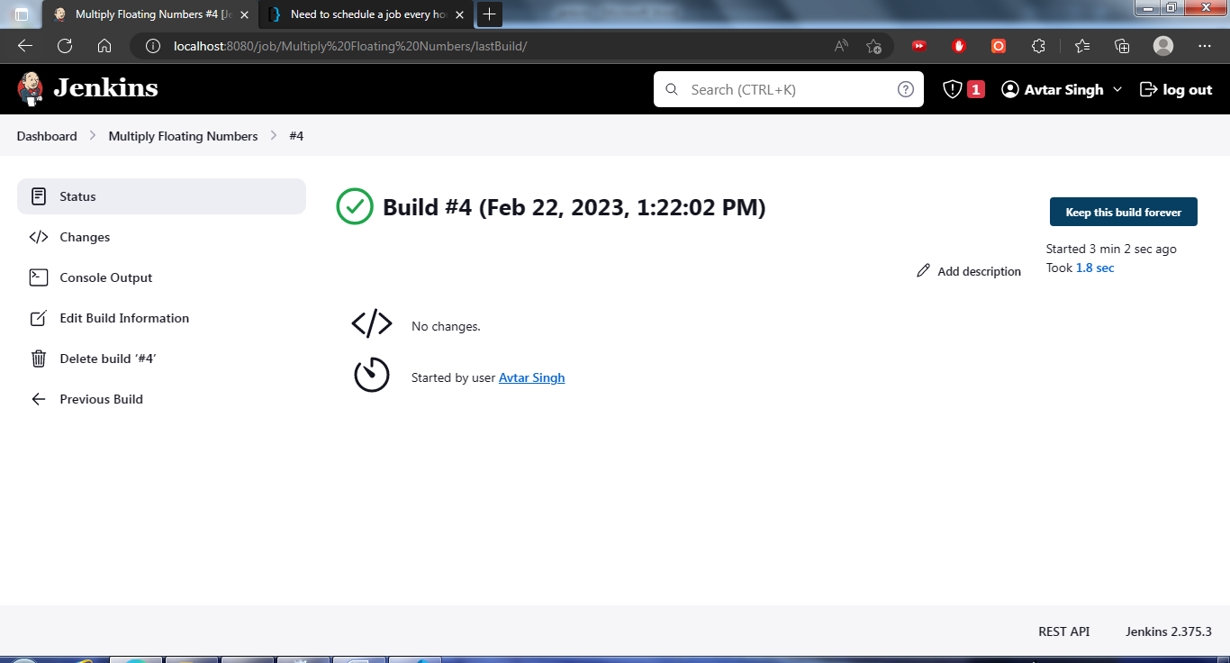

**Marks Obtained -------------------------**

**Maximum Marks------------------------**

**Experiment No: 14**

Student Name and Roll Number: Avtar Singh / 20csu241

Semester /Section: 6th / FSB

Link to Code:

Date: 28/02/2023

Faculty Signature:

Remarks:

**Objective:** Jenkins Chaining - automatically trigger after one job execution

**Student Work Area**

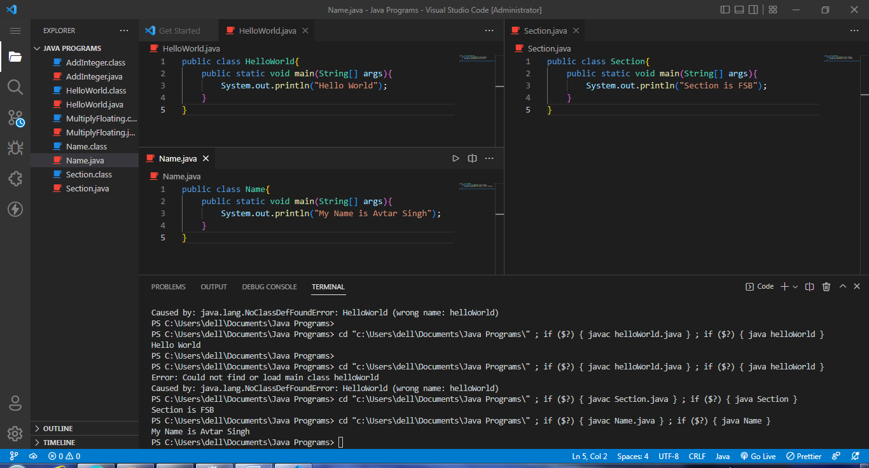

First Project

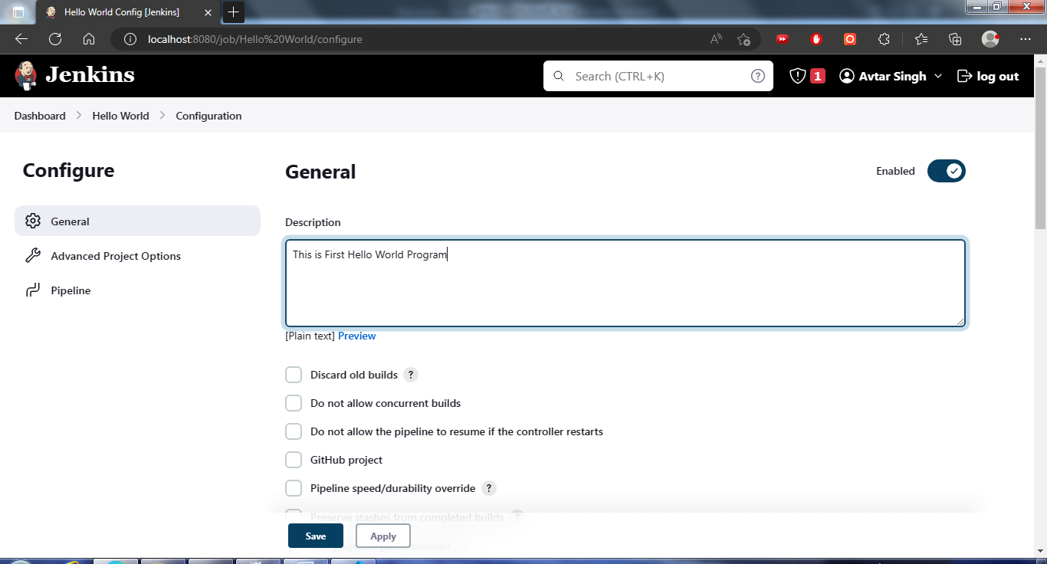

Second Project

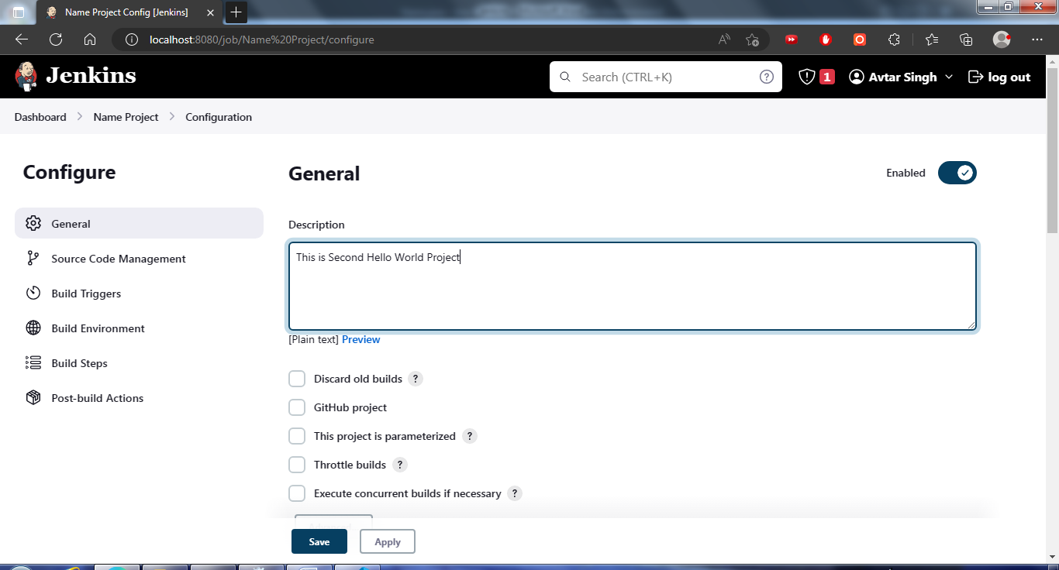

Specifying Other Projects

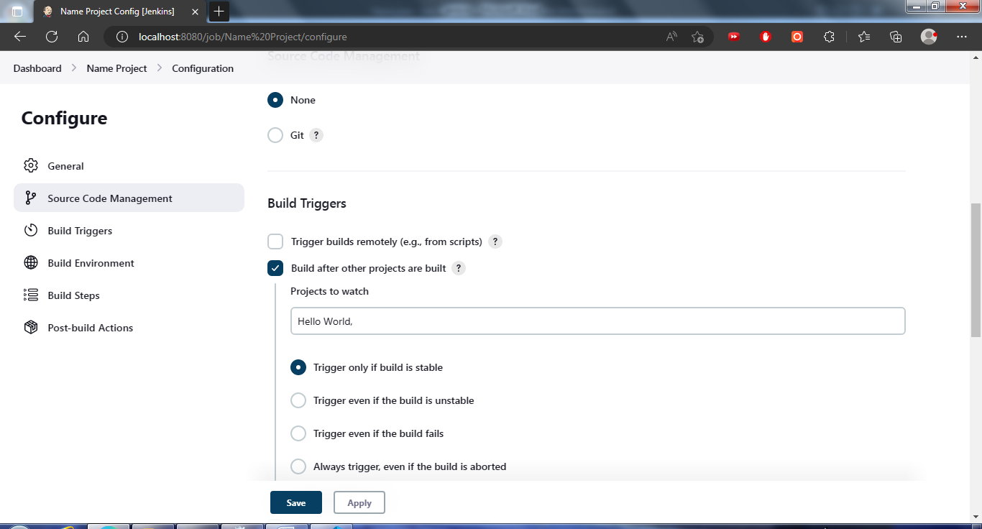

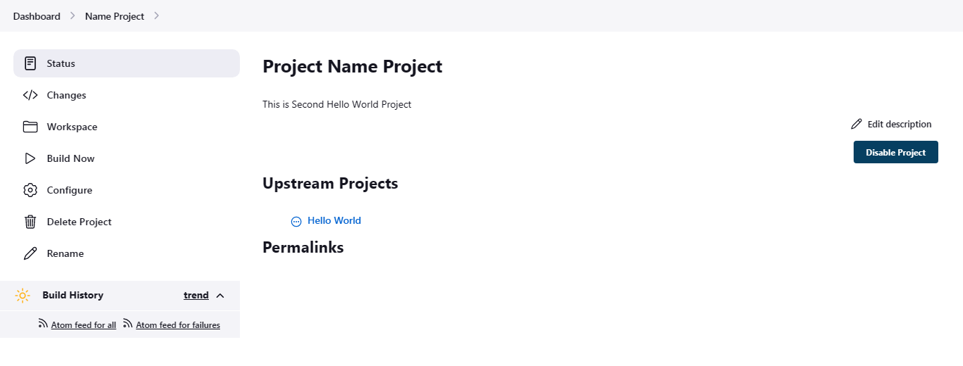

Third Project

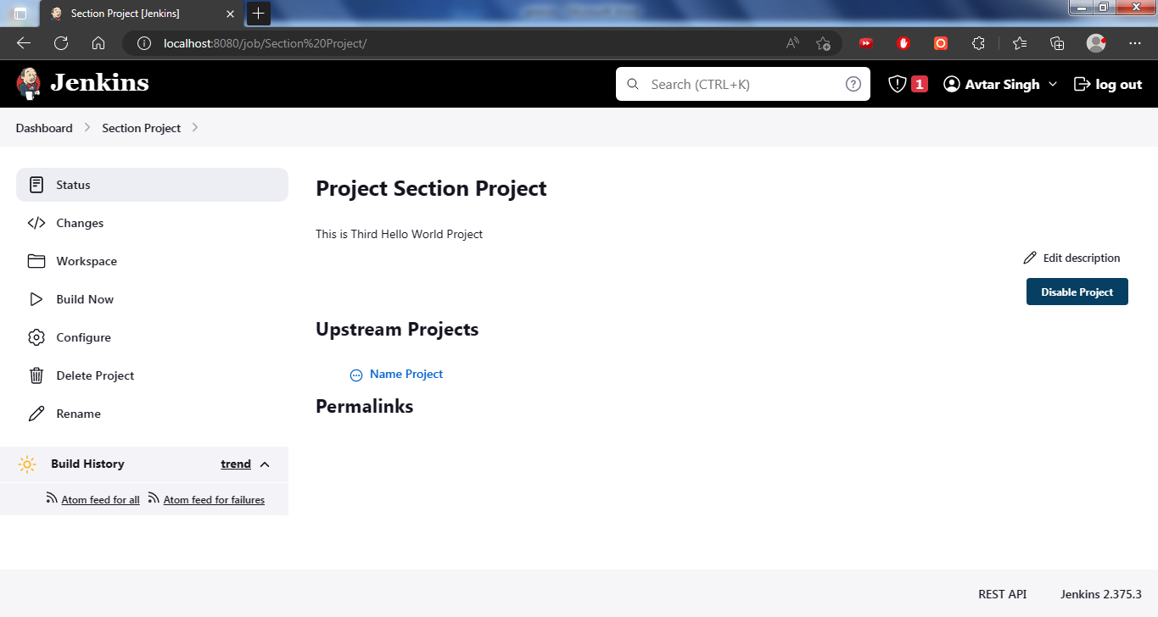

Triggering First Project

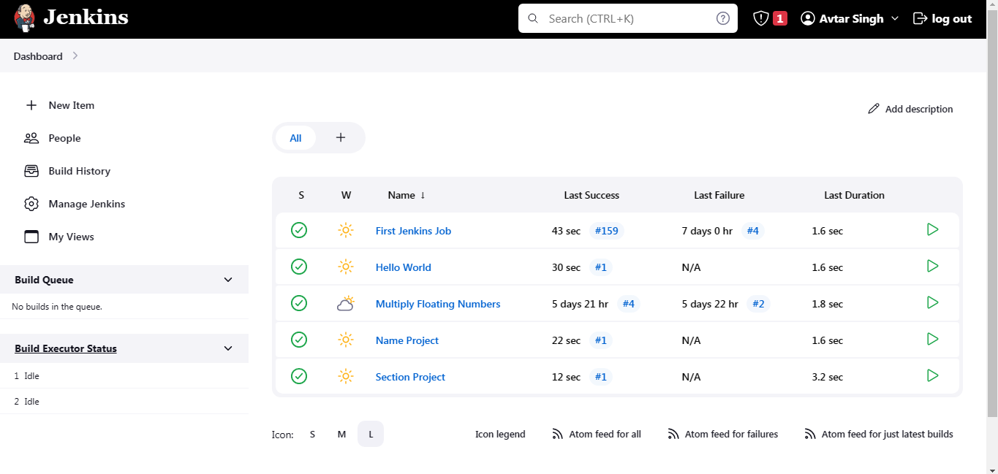

Build History

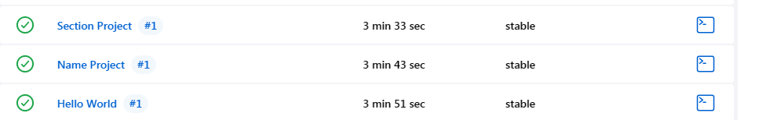

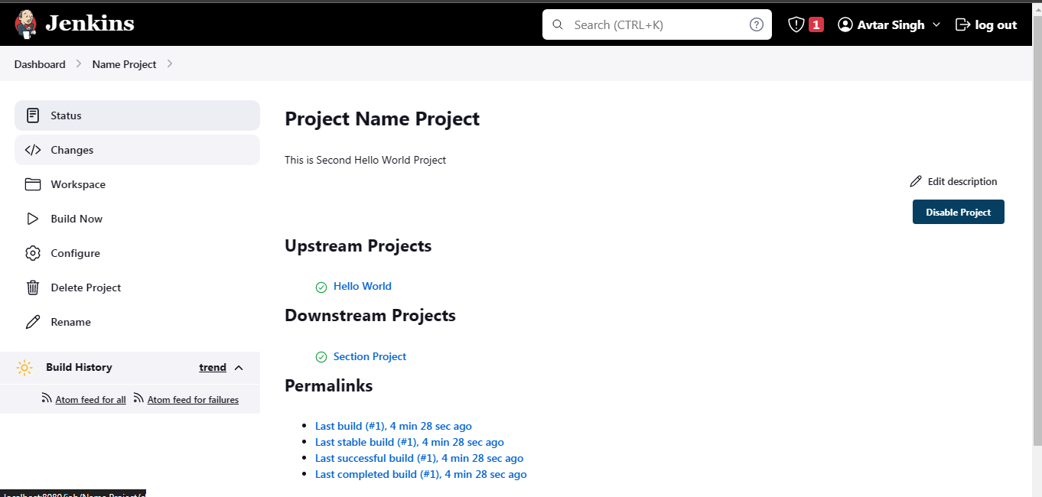

**Marks Obtained -------------------------**

**Maximum Marks------------------------**

**Experiment No: 15**

Student Name and Roll Number: Avtar Singh / 20csu241

Semester /Section: 6th / FSB

Link to Code:

Date: 01/03/2023

Faculty Signature:

Remarks:

**Objective:** Pushing Git files to jenkins and Building it.

**Student Work Area**

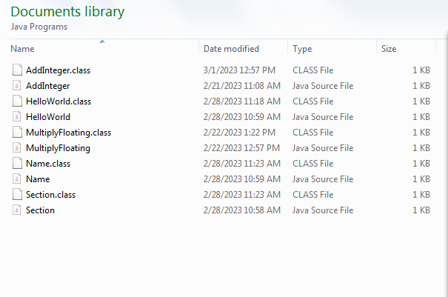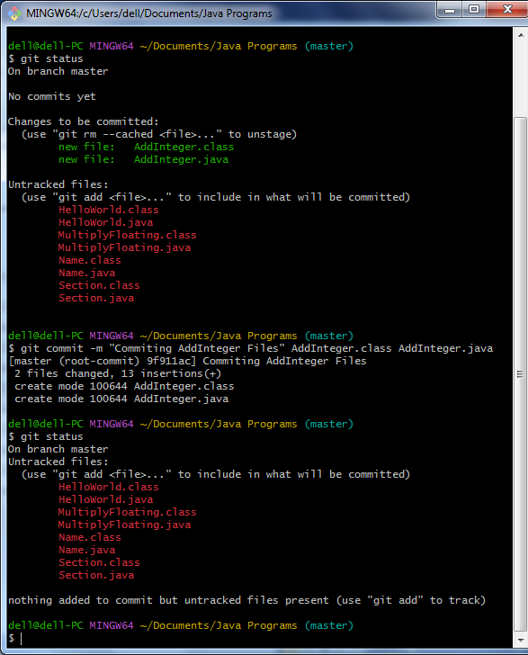

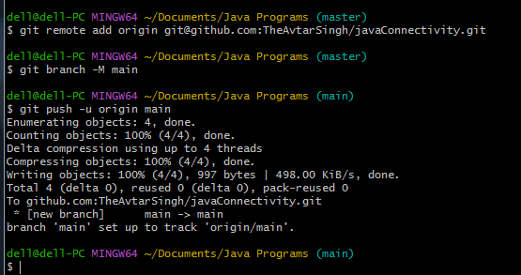

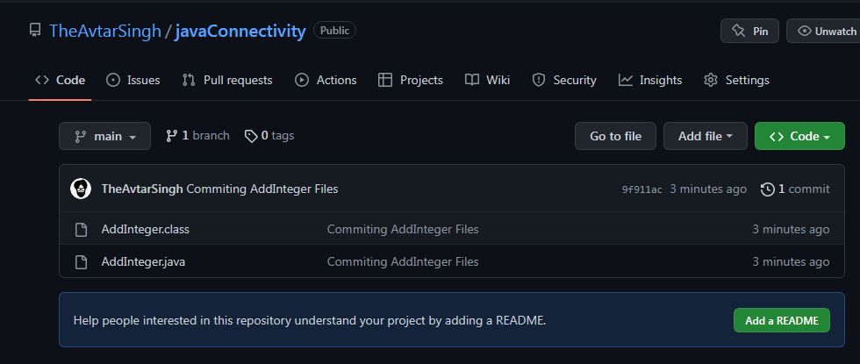

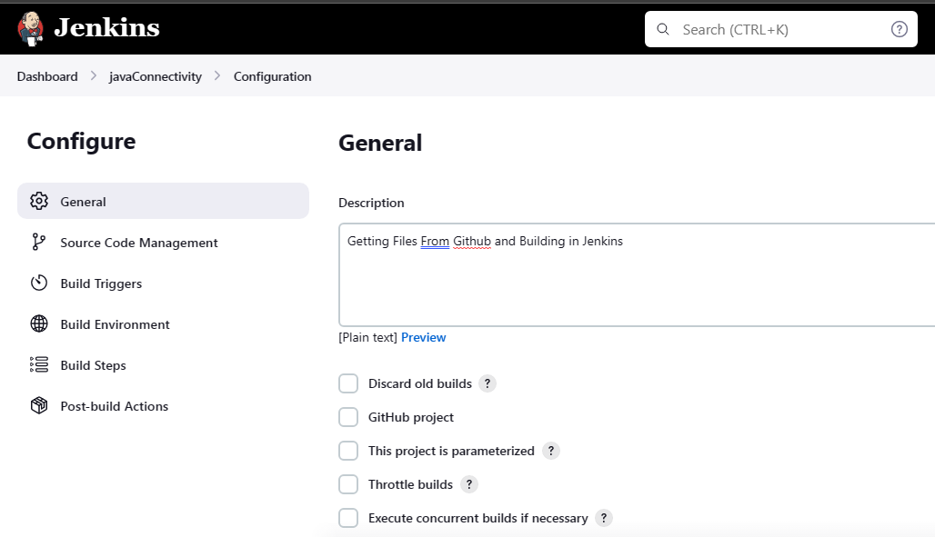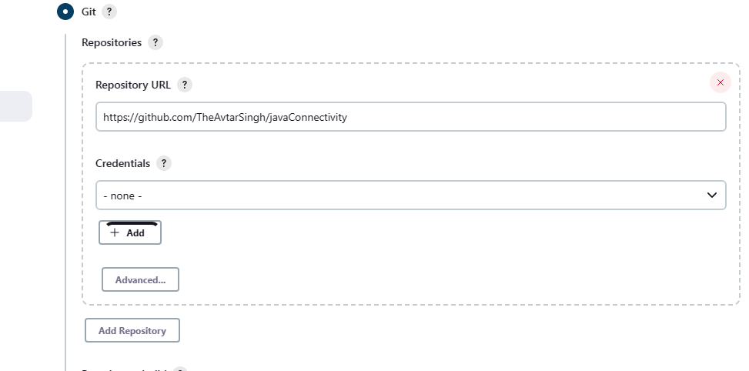

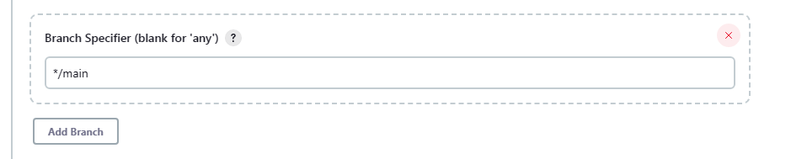

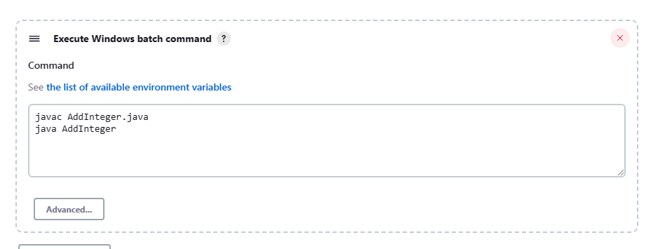

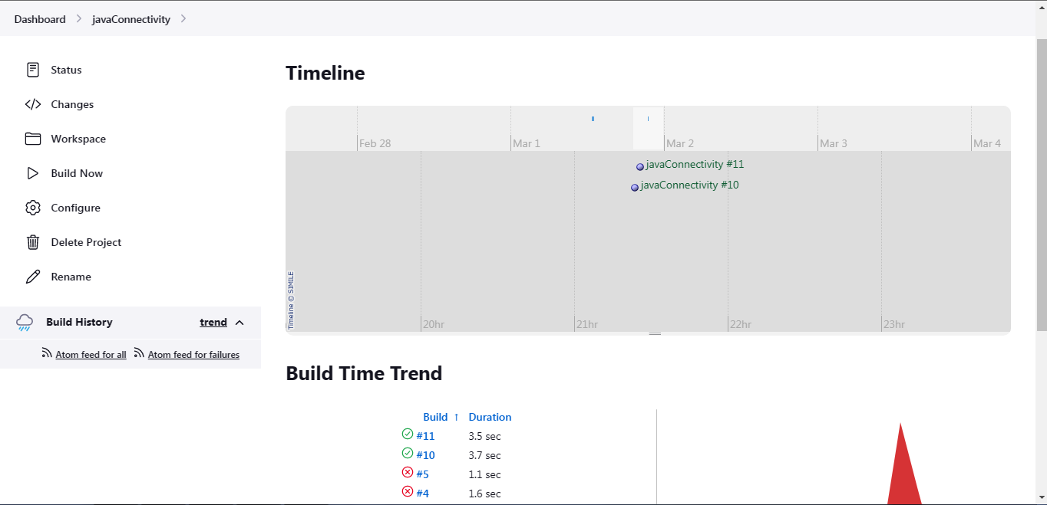

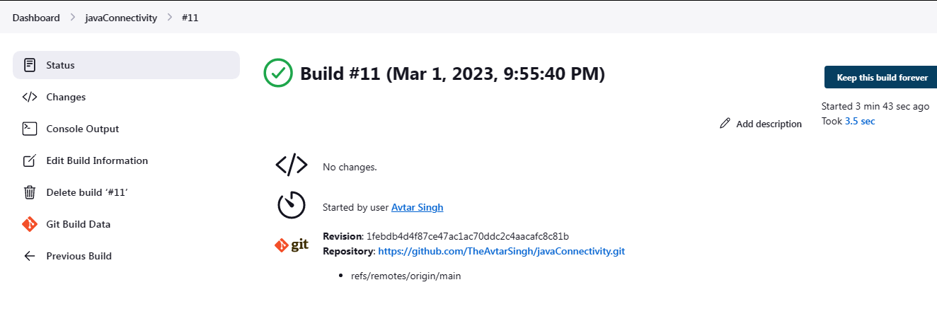

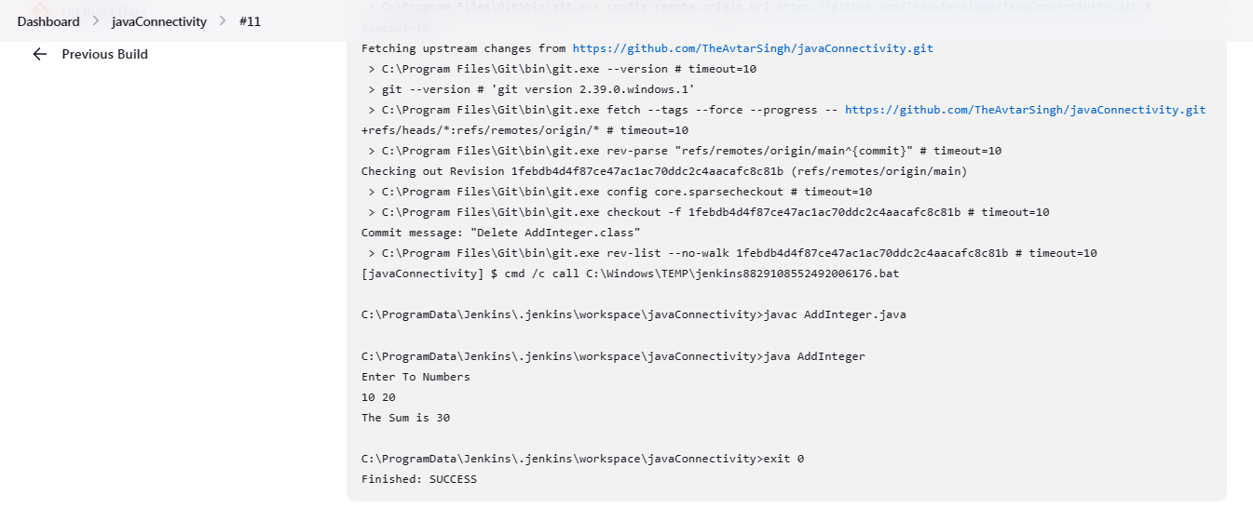

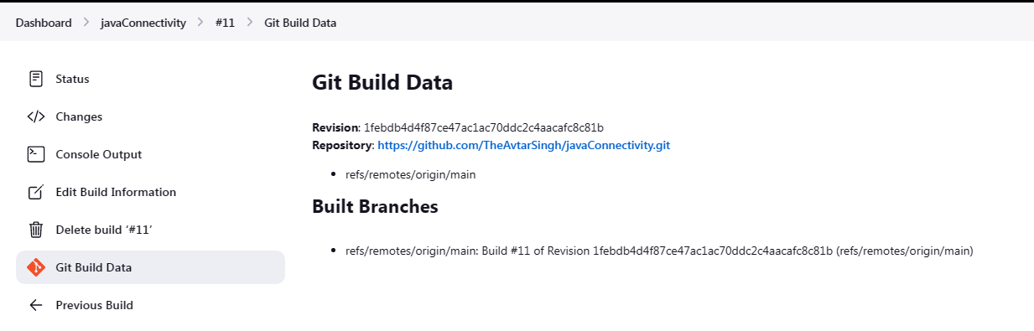

**Marks Obtained -------------------------**

**Maximum Marks------------------------**

**Experiment No: 16**

Student Name and Roll Number: Avtar Singh / 20csu241

Semester /Section: 6th / FSB

Link to Code:

Date: 03/03/2023

Faculty Signature:

Remarks:

**Objective:** Assigning and managing Roles in jenkins.

**Student Work Area**

. Install Plugin

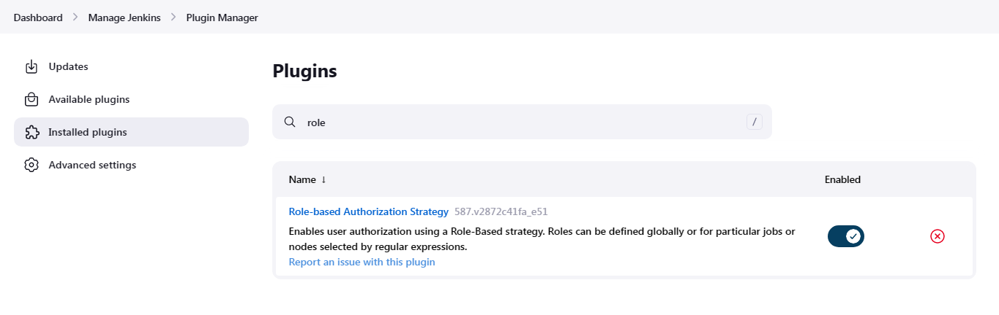

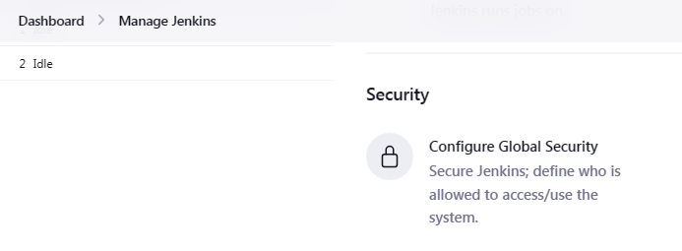

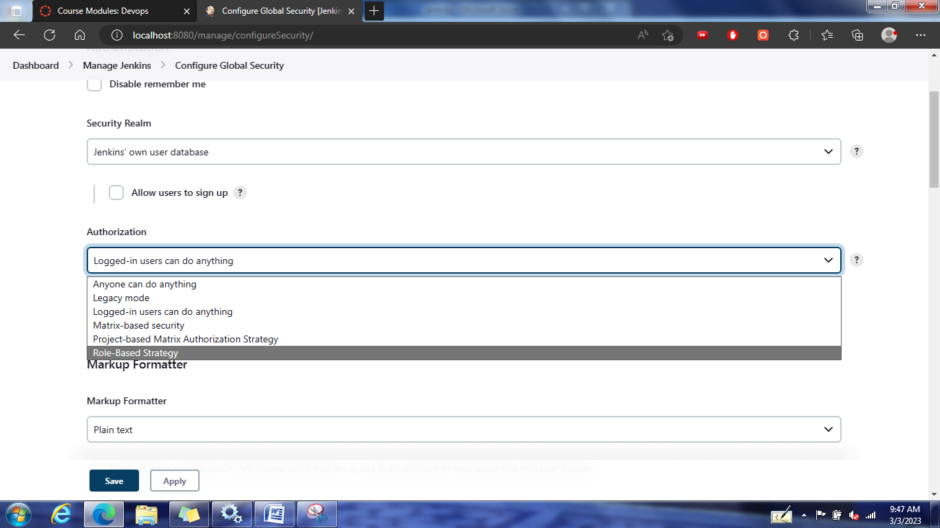

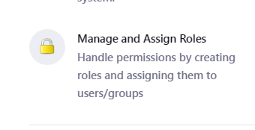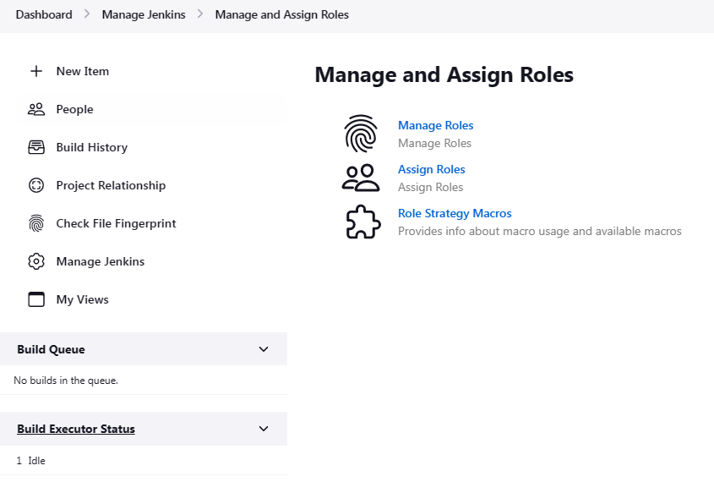

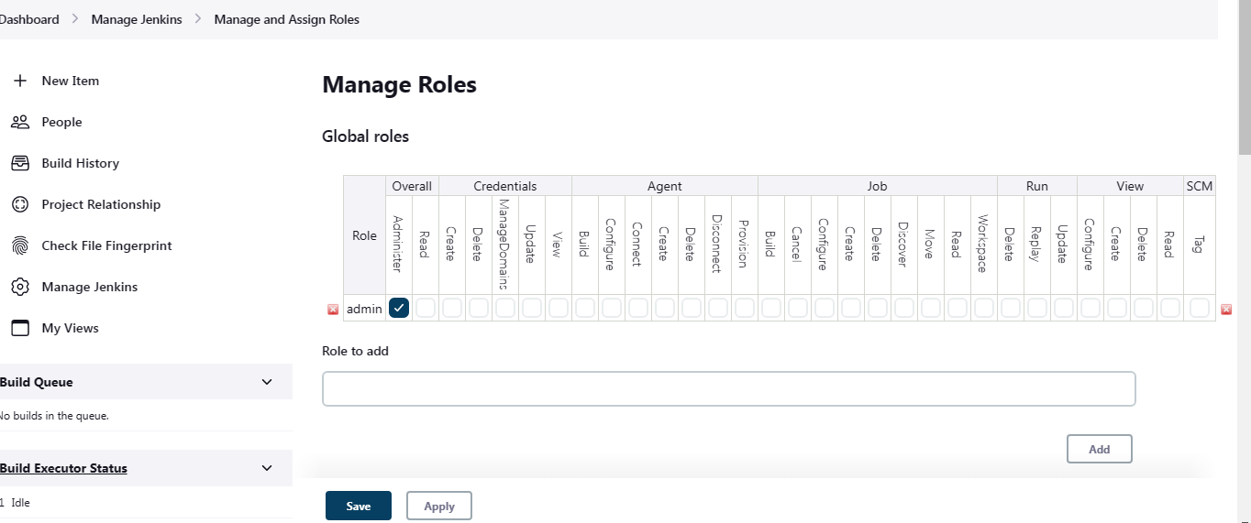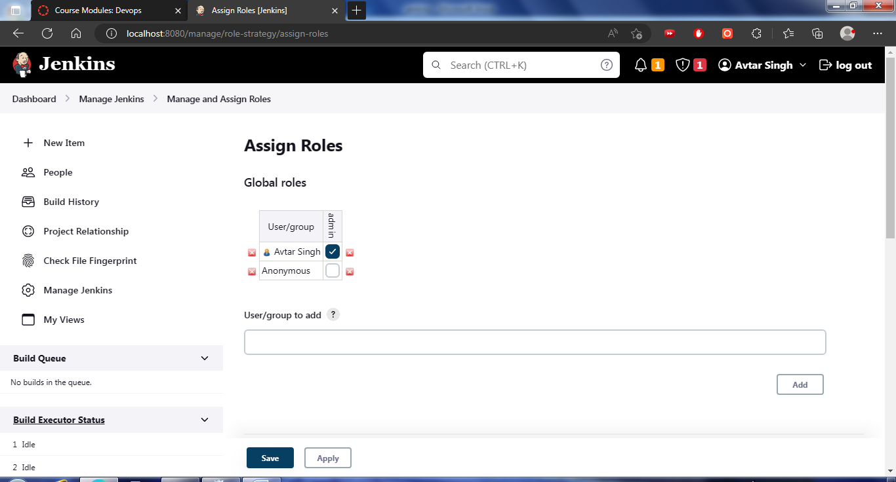

Create New User

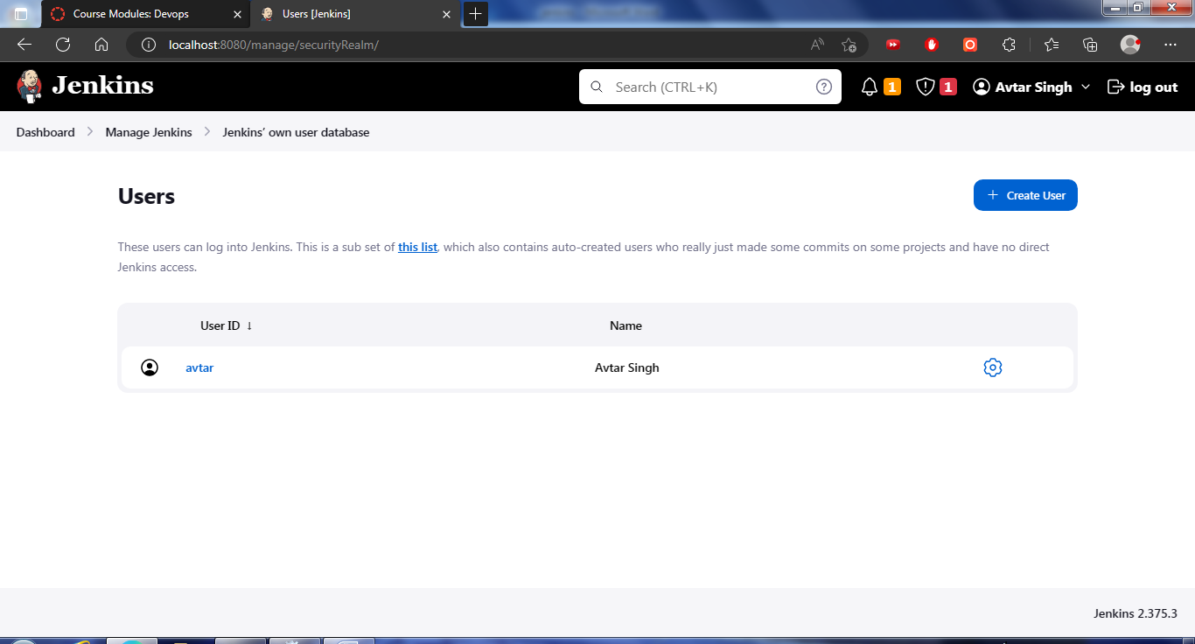

pwd - Harit@123

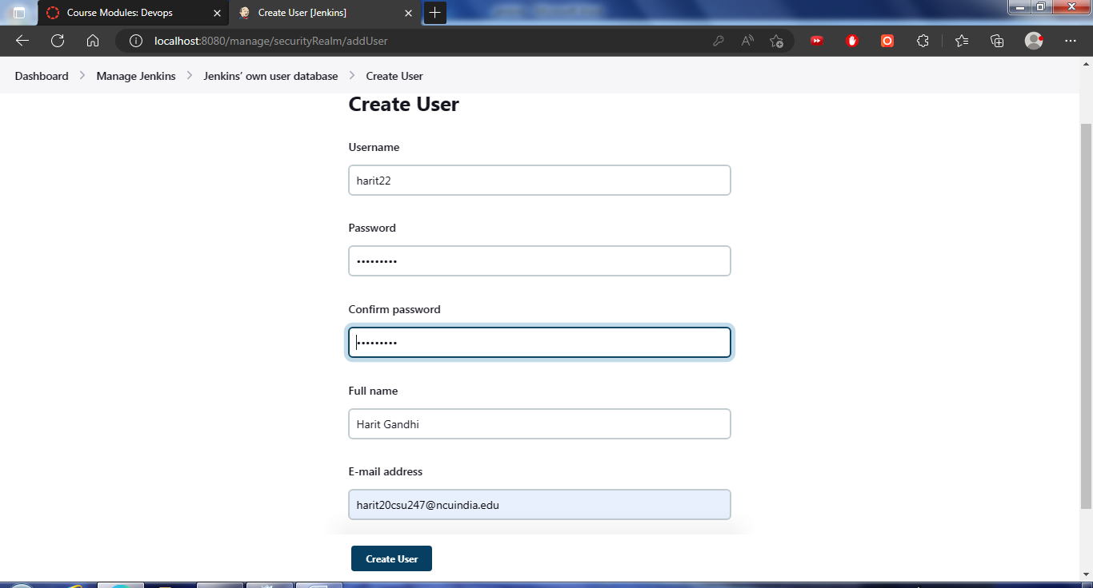

pwd - Sunil@123

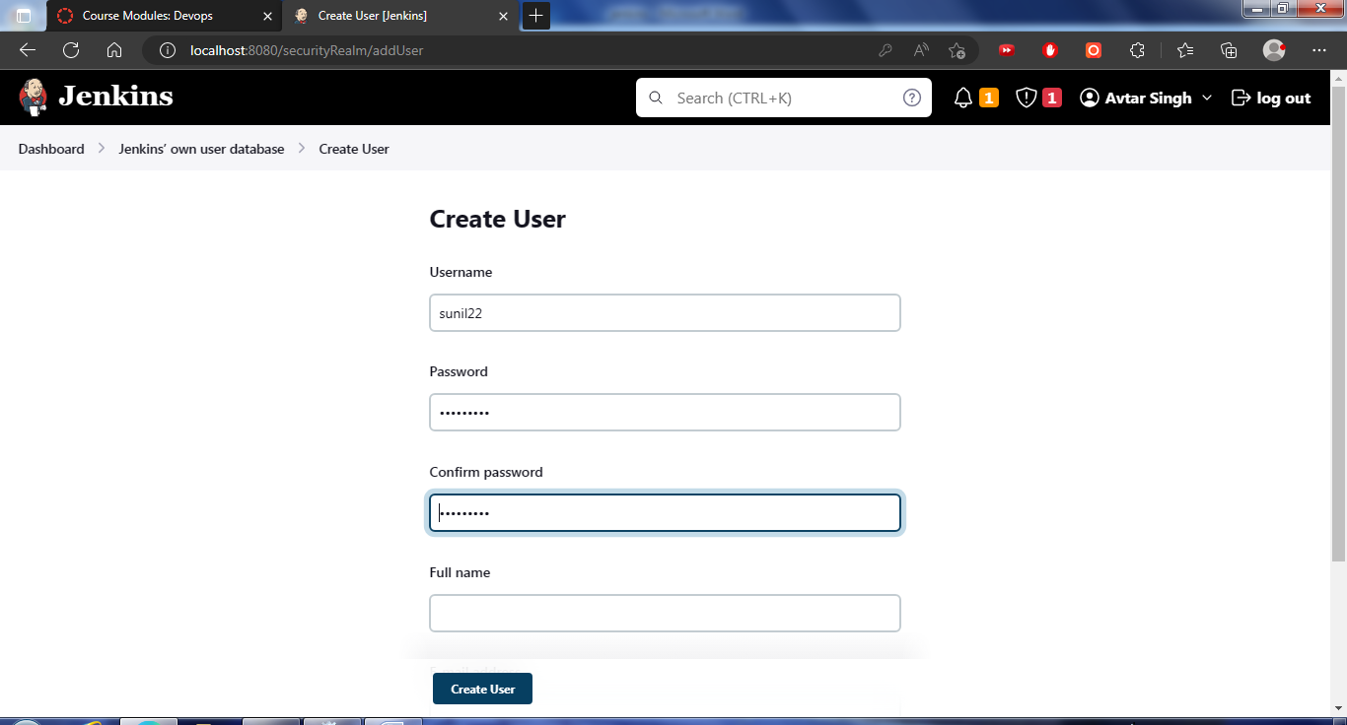

pwd - Jasvinder@123

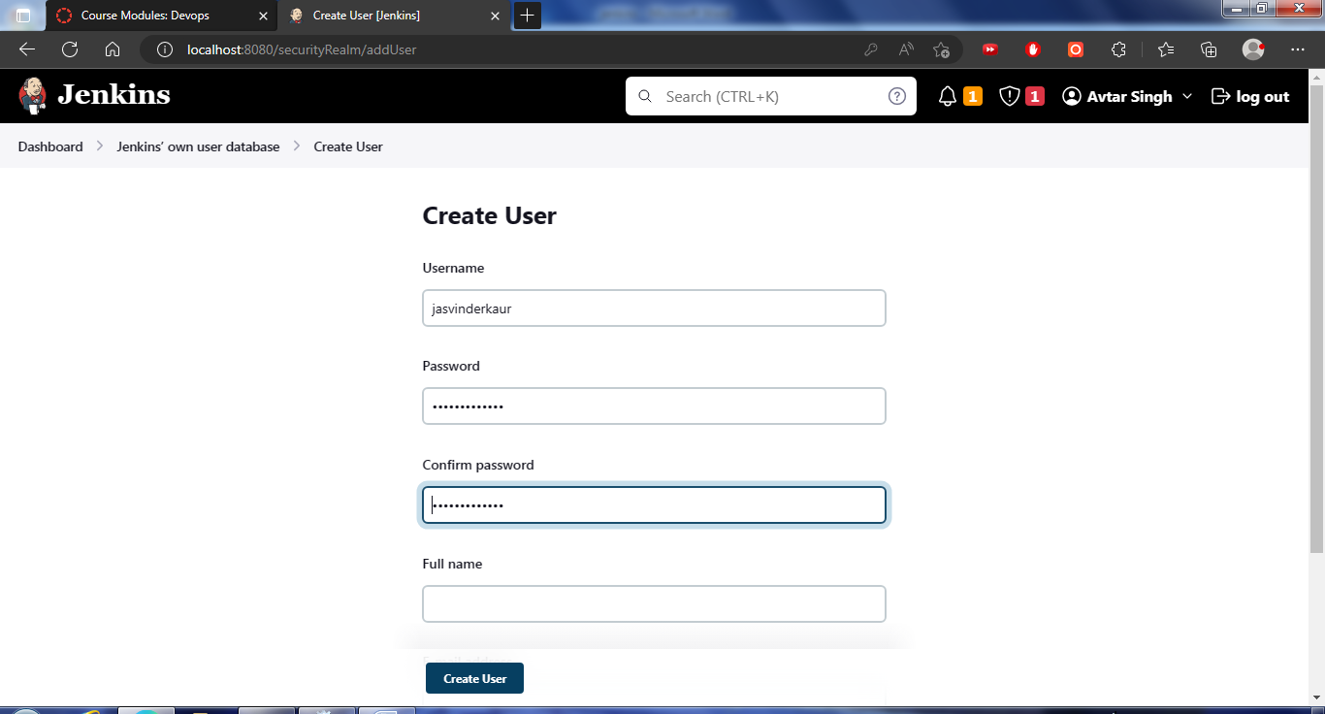

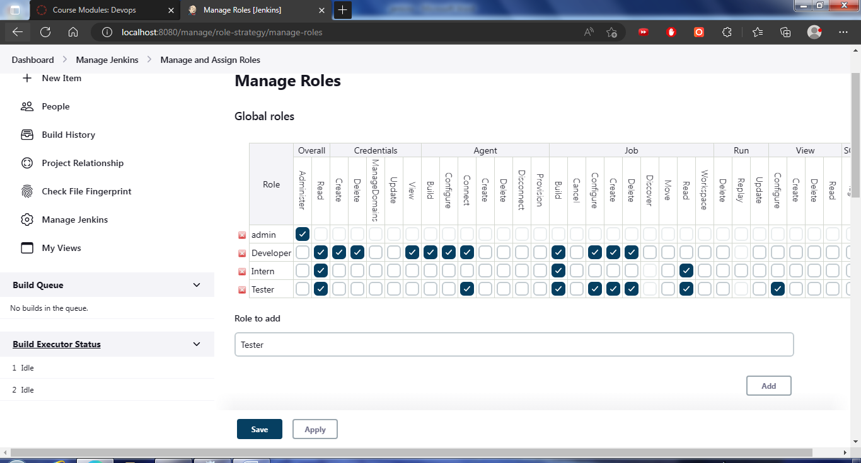

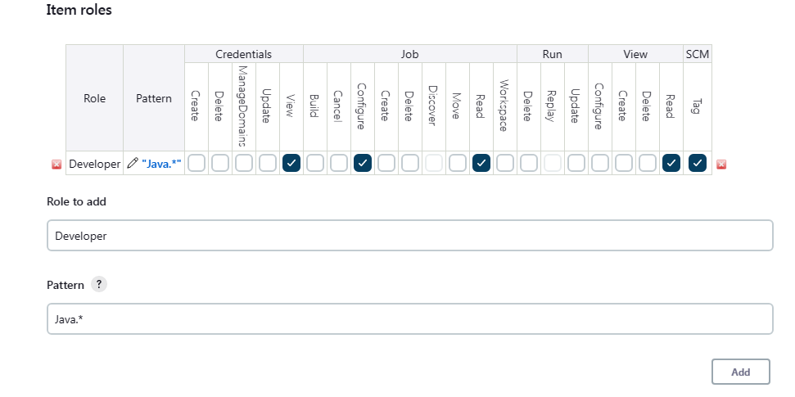

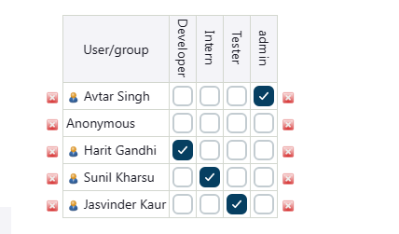

Tester - Can only See Own Credentials

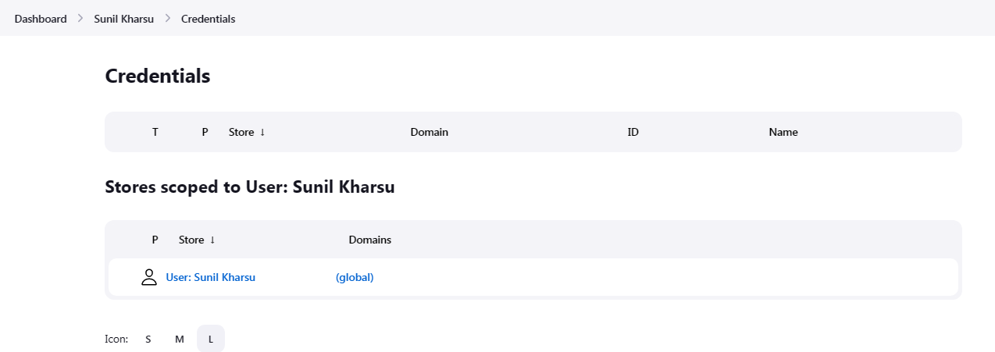

But Developer Can see others too

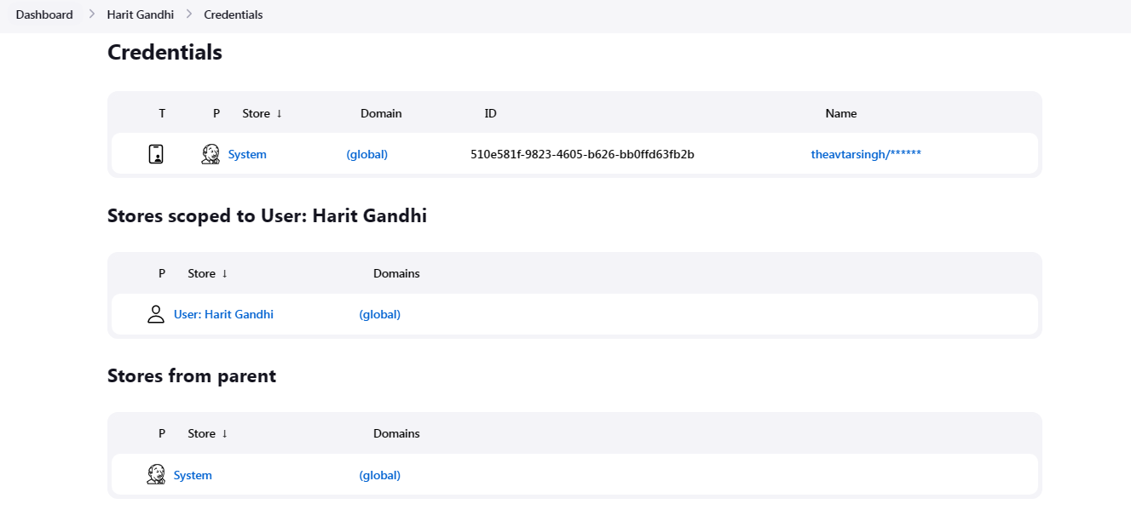

**Marks Obtained -------------------------**

**Maximum Marks------------------------**

**Experiment No: 17**

Student Name and Roll Number: Avtar Singh / 20csu241

Semester /Section: 6th / FSB

Link to Code:

Date: 14/03/2023

Faculty Signature:

Remarks:

**Objective:** Using Maven and Building JAR files.

**Student Work Area**

Creating Jar file with manifest file

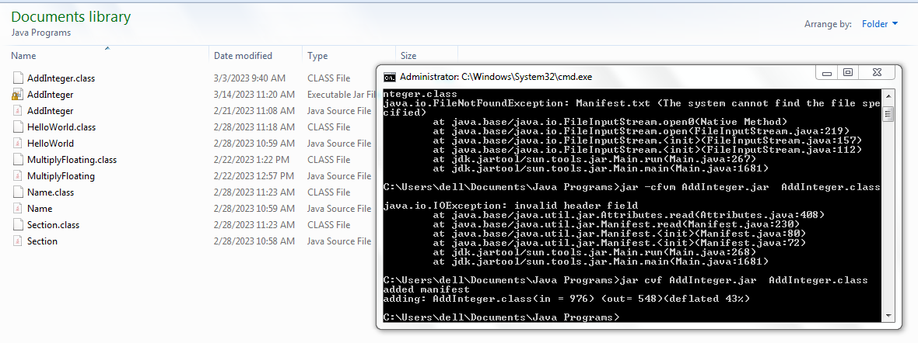

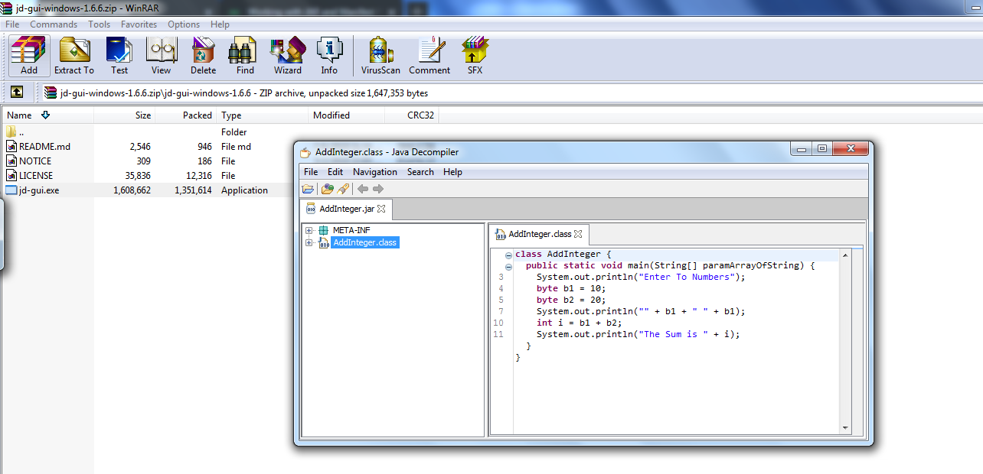



**Marks Obtained -------------------------**

**Maximum Marks------------------------**

**Experiment No: 18**

Student Name and Roll Number: Avtar Singh / 20csu241

Semester /Section: 6th / FSB

Link to Code:

Date: 15/03/2023

Faculty Signature:

Remarks:

**Objective:** Using Catlight for Job Monitoring.

**Student Work Area**

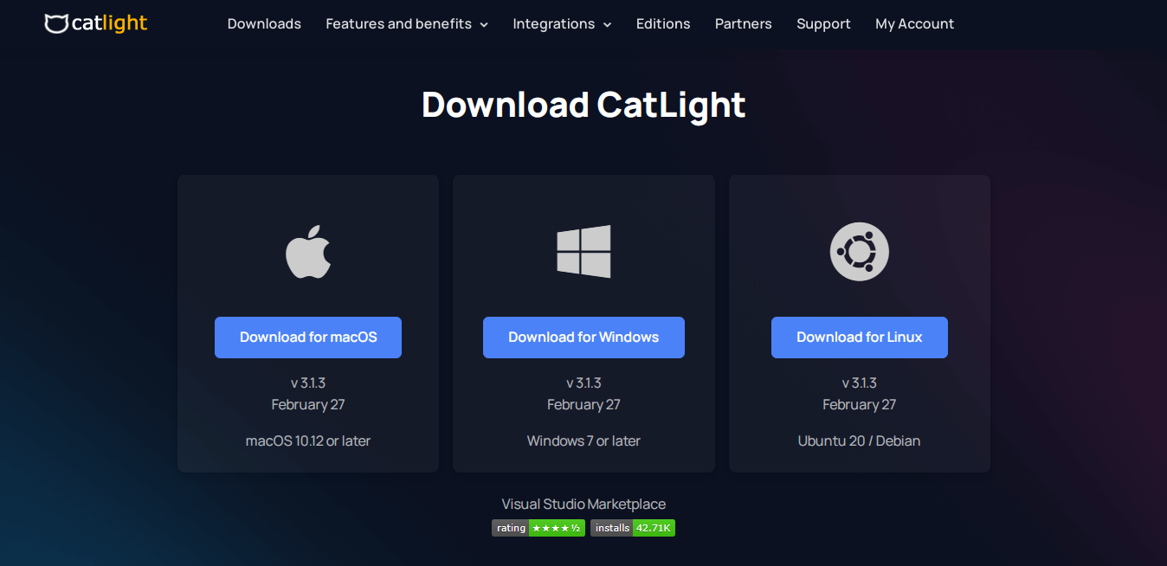

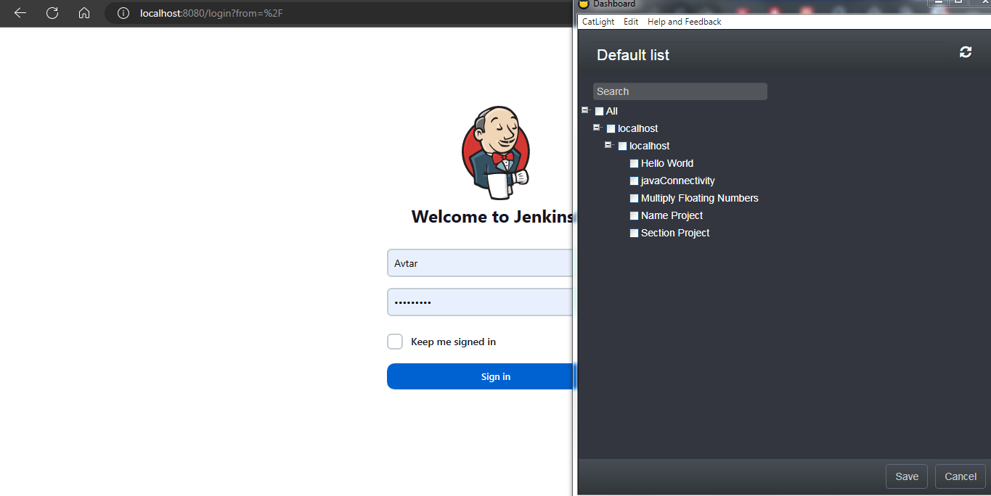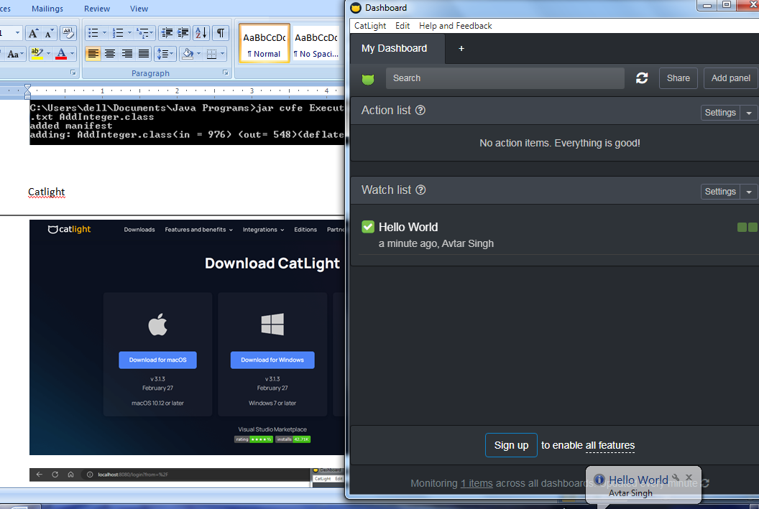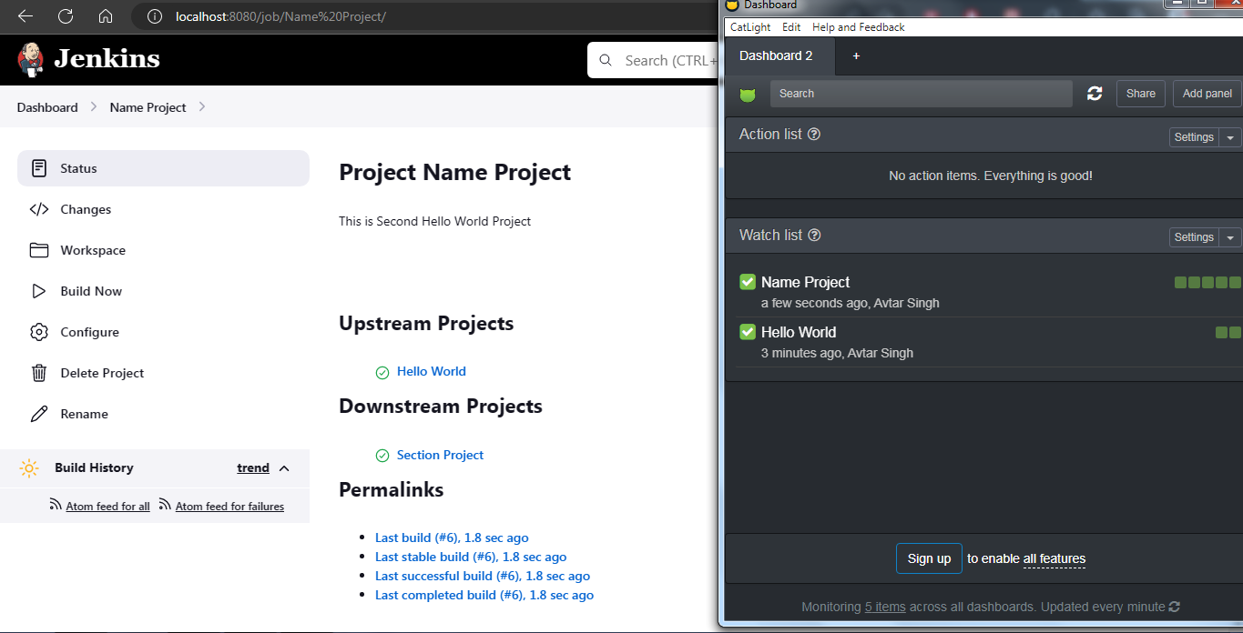

**Marks Obtained -------------------------**

**Maximum Marks------------------------**

**Experiment No: 19**

Student Name and Roll Number: Avtar Singh / 20csu241

Semester /Section: 6th / FSB

Link to Code:

Date: 06/04/2023

Faculty Signature:

Remarks:

**Objective:** Configuring Docker and Clone Image.

**Student Work Area**

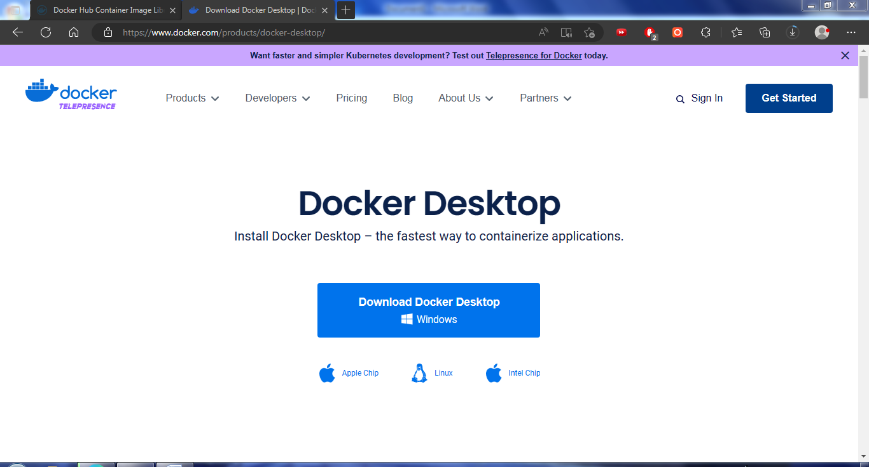

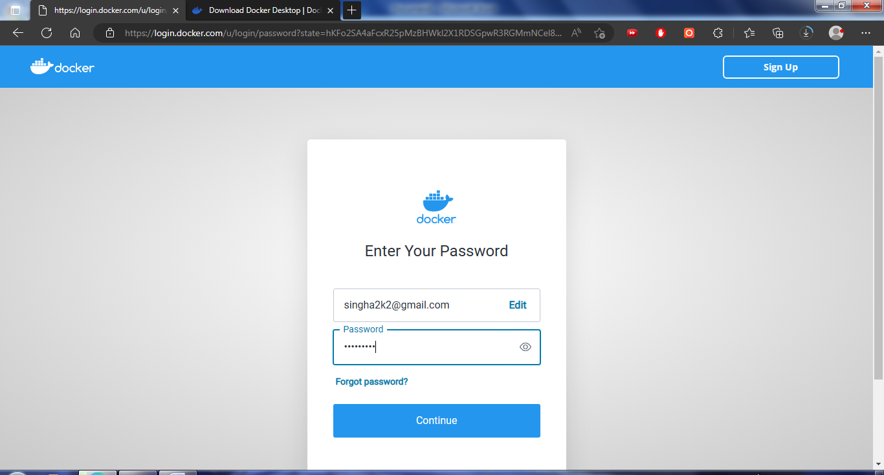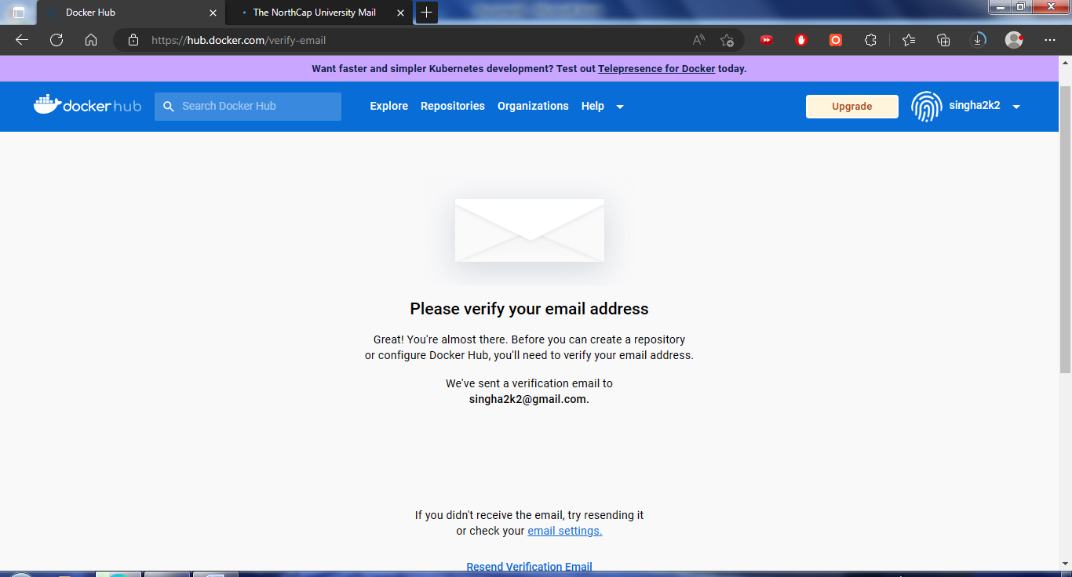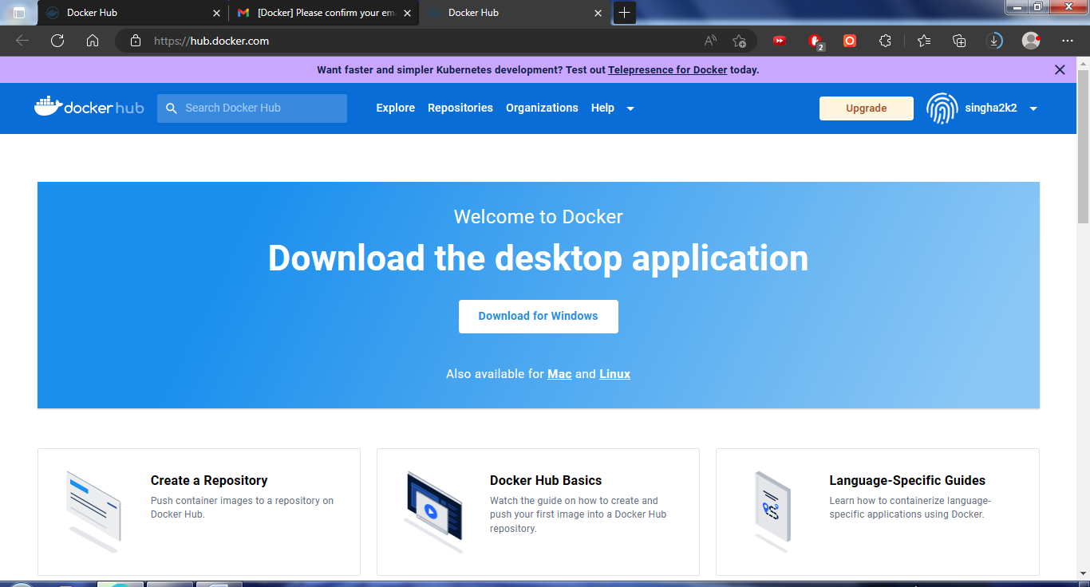

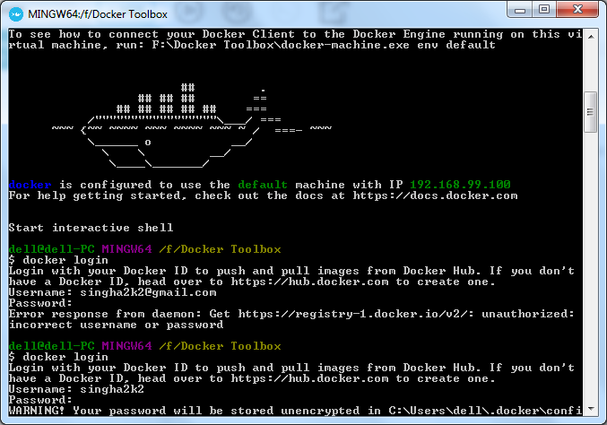

Cloning Image from Github

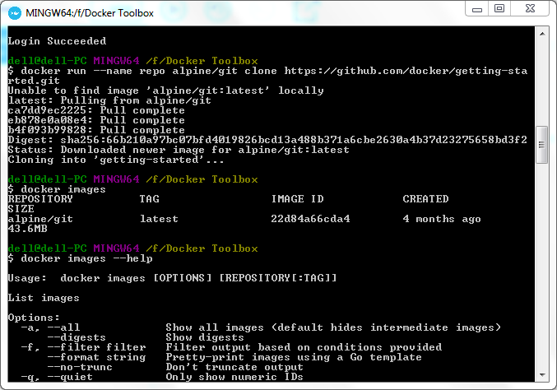

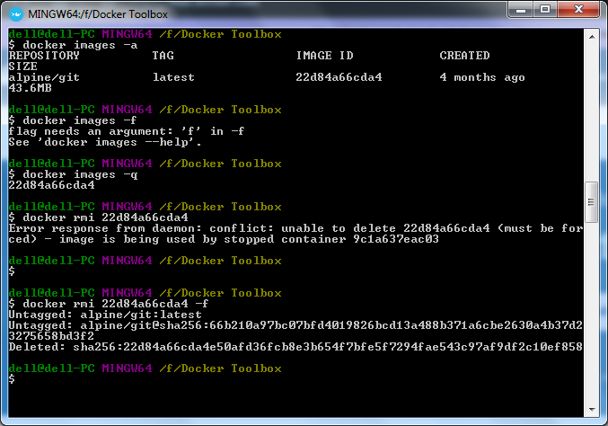

**Marks Obtained -------------------------**

**Maximum Marks------------------------**

**Experiment No: 20**

Student Name and Roll Number: Avtar Singh / 20csu241

Semester /Section: 6th / FSB

Link to Code:

Date: 11/04/2023

Faculty Signature:

Remarks:

**Objective:** Docker Basic Concepts.

**Student Work Area**

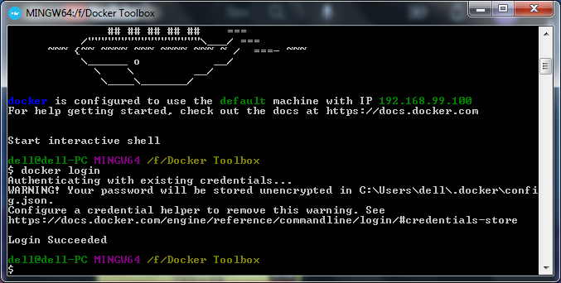

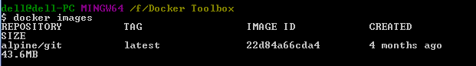

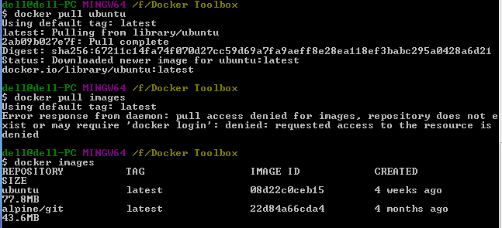

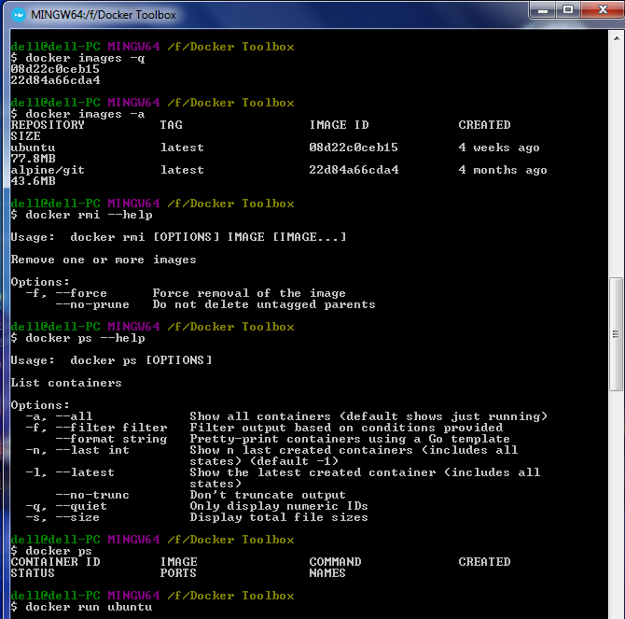

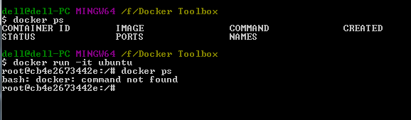

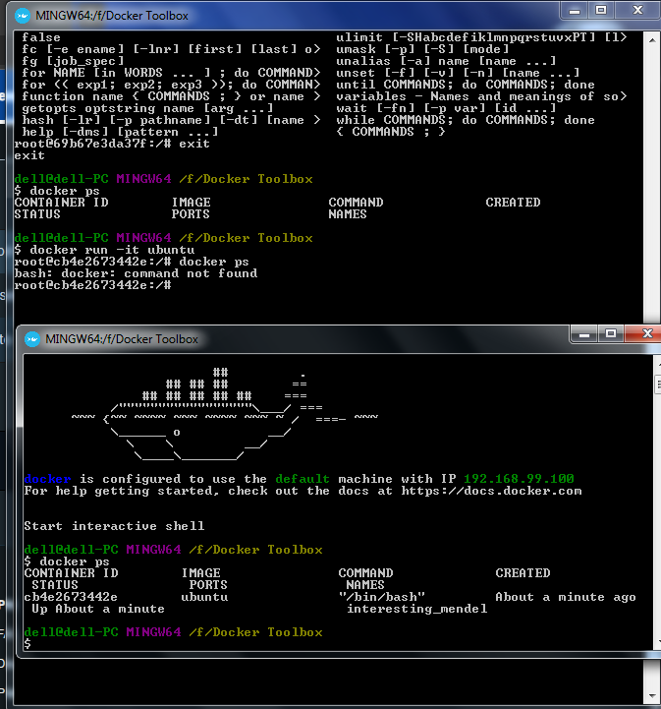

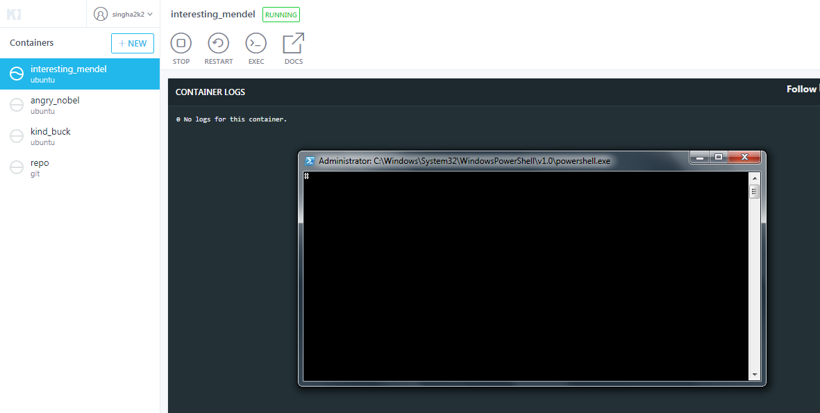

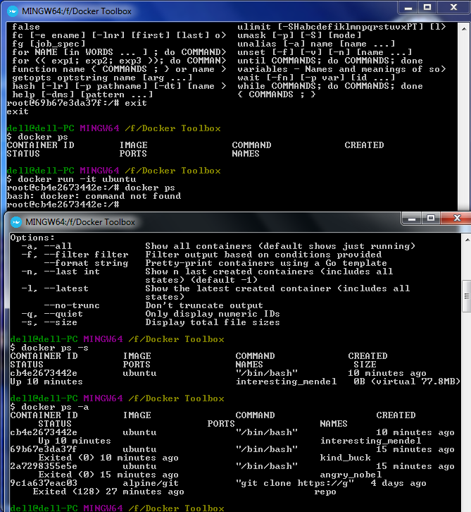

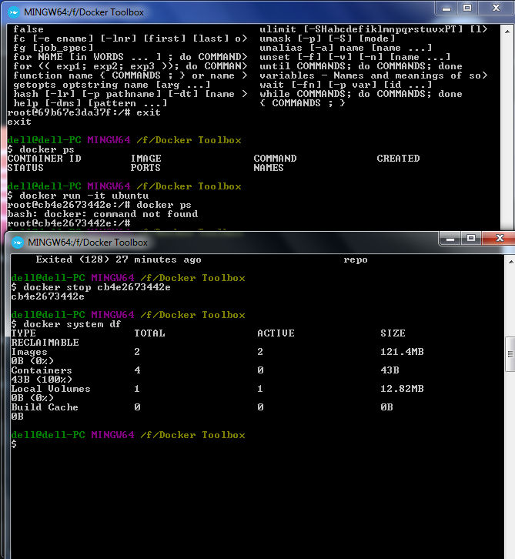

**Marks Obtained -------------------------**

**Maximum Marks------------------------**

**Experiment No: 21**

Student Name and Roll Number: Avtar Singh / 20csu241

Semester /Section: 6th / FSB

Link to Code:

Date: 18/04/2023

Faculty Signature:

Remarks:

**Objective:** Docker Networking.

**Student Work Area**

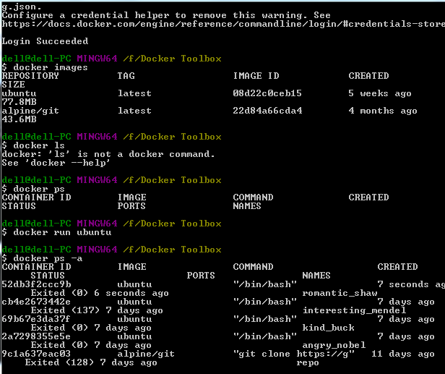

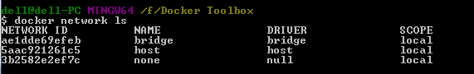

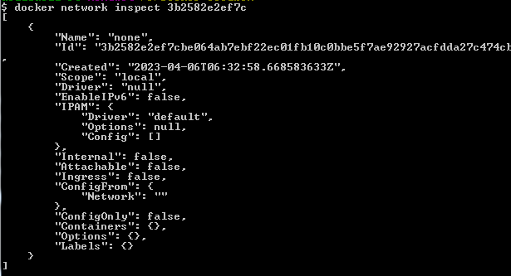

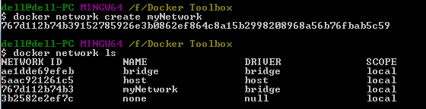







**Marks Obtained -------------------------**

**Maximum Marks------------------------**

**Experiment No: 22**

Student Name and Roll Number: Avtar Singh / 20csu241

Semester /Section: 6th / FSB

Link to Code:

Date: 25/04/2023

Faculty Signature:

Remarks:

**Objective:** Importing Redis and Busybox and Using them for Pinging.

**Student Work Area**

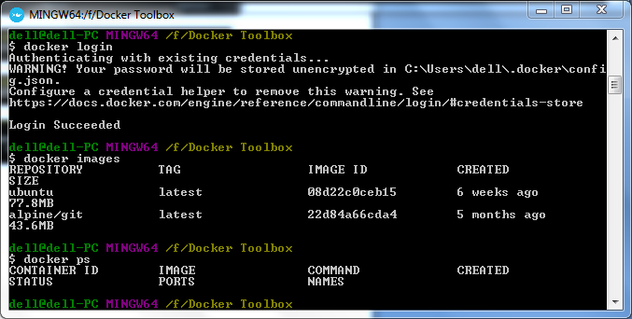

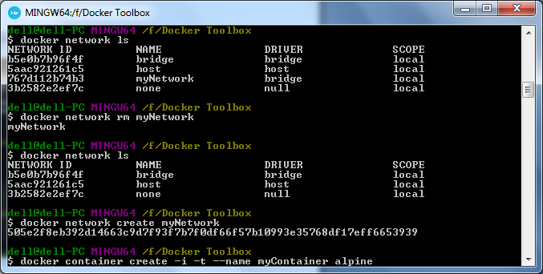

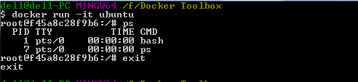

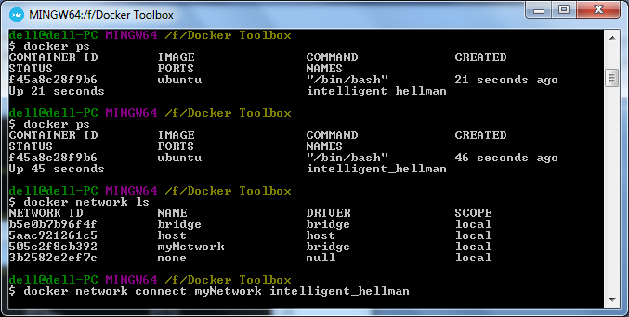

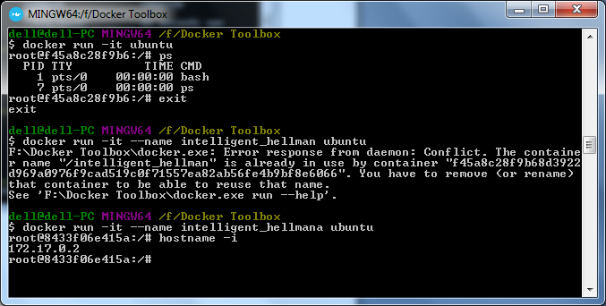

Redis and BusyBox

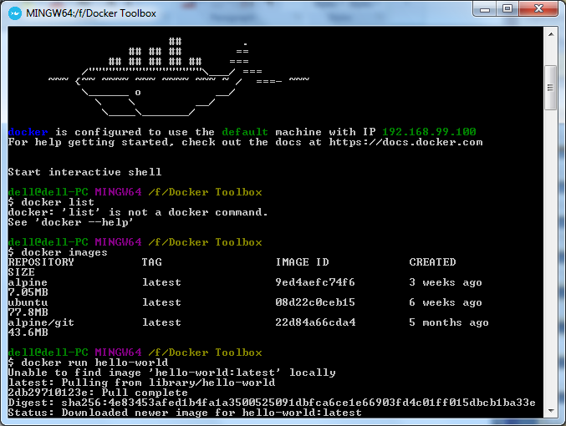

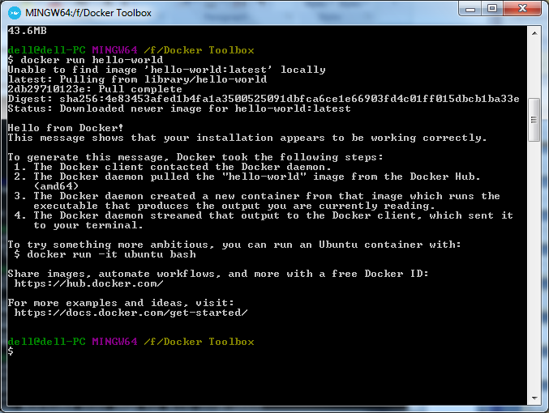

This time no pulling is done

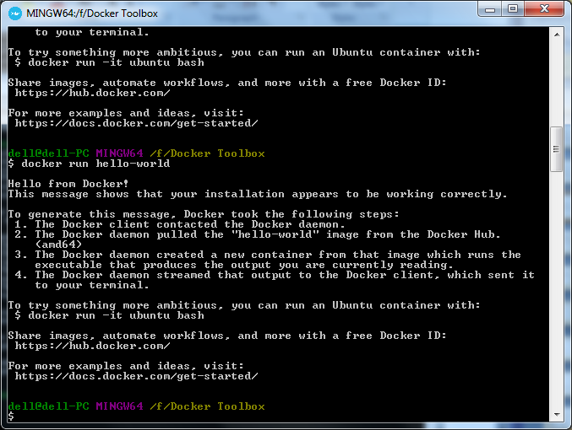

BusyBox - Lite Linux Version

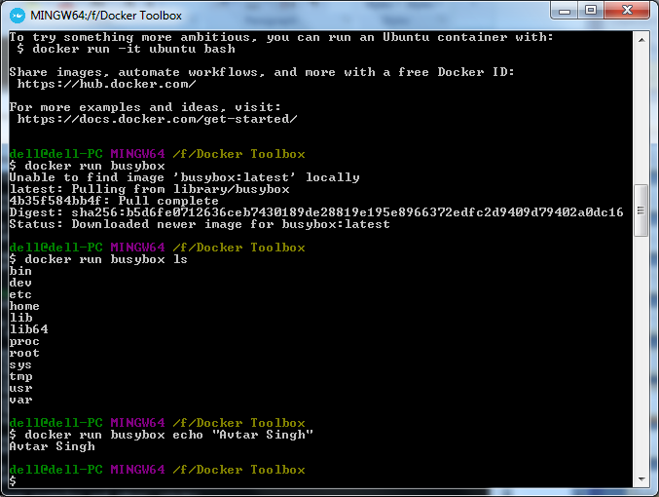

Running on Busybox vs Helloworld

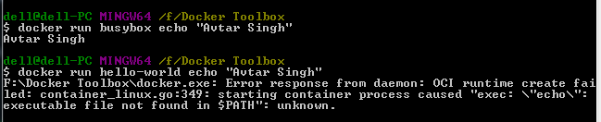

History

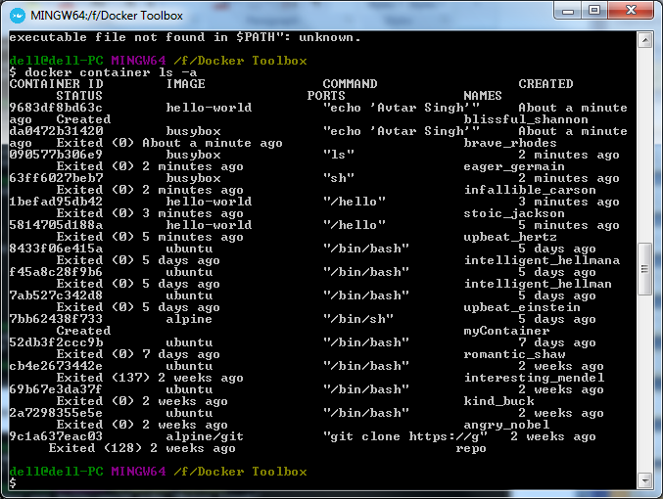

Created Container

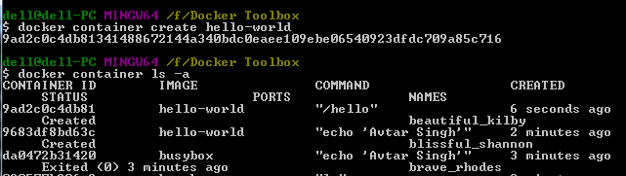

Starting

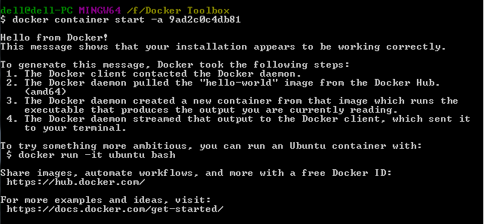

pinging from windows

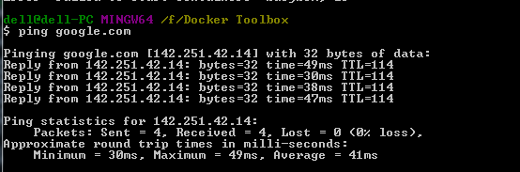

pinging from busybox

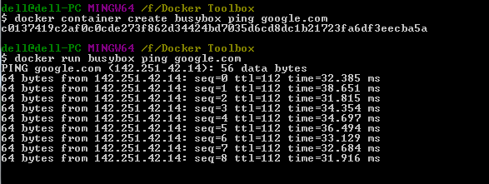

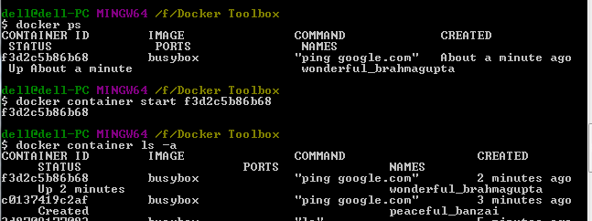

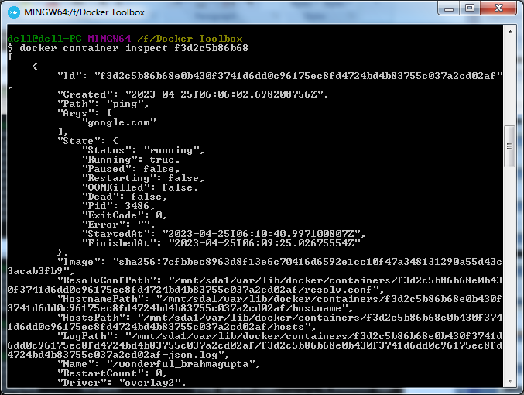

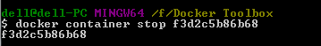

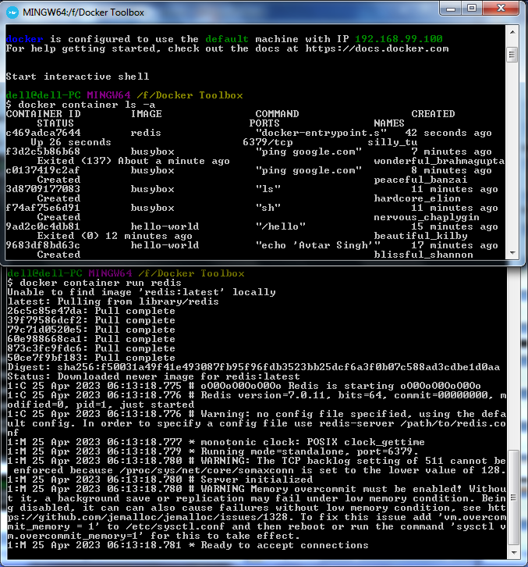

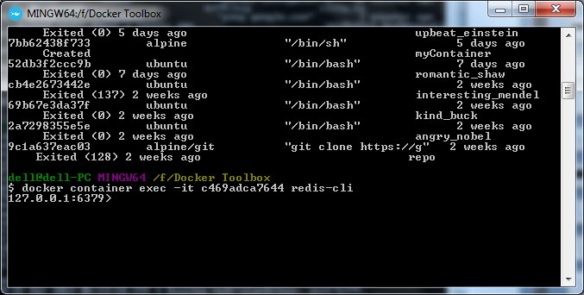

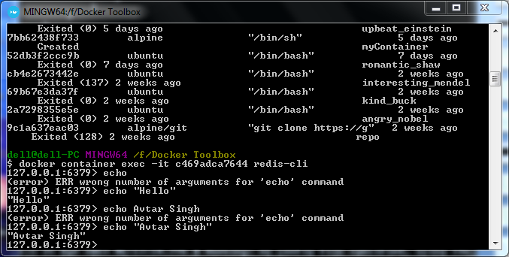

**Marks Obtained -------------------------**

**Maximum Marks------------------------**